Study Guide
8th Grade Number Sense Review
05/18/2016

Multiplying More Than Two Integers
Integers are the set of positive and negative whole numbers, including zero. Students should understand how integers appear on a number line.
Numbers to the right of 0 on a number line are positive and numbers to the left of 0 are negative. The number - 3 is a negative integer and the number 3 is a positive integer. The integer 0 is neutral.

There are rules regarding the multiplication of positive and negative integers:
• The product of two positive numbers is positive. For example, (9)(4) = 36.
• The product of two negative numbers is positive. For example, (- 9)(- 4) = 36.
• The product of a positive number and a negative number is negative. For example, (9)(- 4) = - 36.
Notice from the examples shown above that when multiplying numbers with the same sign, the answer is positive. When multiplying numbers with different signs, the answer is negative.
Multiplying More Than Two Integers:
When multiplying more than two integers, the rules for multiplication are similar to the rules above:
• The product of an even number of negative integers (for example multiplying 2, 4, 6, or 8 negative integers), is a positive number. For example, (- 3)(- 2)(- 7)(-1) = 42.
• The product of an odd number of negative integers (for example 3, 5, 7, or 9 negative integers), is a negative number. For example, (- 3)(- 2)(- 7) = - 42.
• No matter how many positive integers are multiplied together, the answer will always be positive.
Example 1: Multiply.
(- 5)(- 6)(2)(31) =
(1) (5)(6)(2)(31) = 1,860
(2) ( - )( - )( + )( + ) = +
Step 1: Multiply the numbers from left to right, disregarding the negative signs.
Step 2: Count the number of negative signs in the problem. There is an even number of negative signs, so the product found in step 1 is a positive number.
Answer: 1,860
Example 2: Multiply.
(7)(- 6)(4)(30) =
(1) (7)(6)(4)(30) = 5,040
(2) ( + )( - )( + )( + ) = -
Step 1: Multiply the numbers from left to right, disregarding the negative signs.
Step 2: Count the number of negative signs in the problem. There is an odd number of negative signs, so the product found in step 1 is a negative number.
Answer: - 5,040
An activity that can help reinforce the concept of multiplying integers involves making up problems for the student. Tell the student how many positive and how many negative numbers there are in a problem. Then ask him or her to figure out whether the product is positive or negative without calculating the answer.

Add Fractions: Mixed Numbers - B
Adding mixed fractions requires an understanding of adding fractions and the multiplication facts. If the numerator (the number on the top of a fraction) is less than the denominator (the number on the bottom of a fraction), the fraction is called a proper fraction. If the numerator is equal to or greater than the denominator, the fraction is called an improper fraction. An improper fraction can be rewritten as a mixed number. For example, 5/3 is an improper fraction. It can be rewritten as 1 2/3, which is a mixed number.

Example 1: Solve.
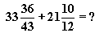
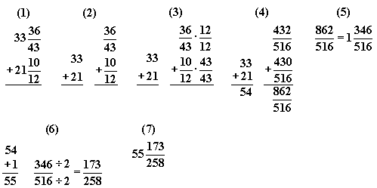
Step 1: Rewrite the problem vertically.
Step 2: Separate the problem into addition of whole numbers and addition of fractions.
Step 3: Find a common denominator (a common multiple of the denominators of two or more fractions) for the fractions. The simplest way to find a common denominator is to multiply all the denominators together. For this problem, the common denominator is 516 because 12 x 43 = 516. Multiply 36/43 by 12/12. Multiply 10/12 by 43/43.
Step 4: Add the whole numbers (33 + 21 = 54). Add the numerators (432 + 430 = 862). The denominator remains the same (516).
Step 5: 862/516 is an improper fraction, so it must be rewritten as a mixed number. Since 516 will divide into 862 one time with 346 left over, 862/516 can be rewritten as 1 346/516.
Step 6: Add the whole numbers (54 + 1 = 55). Since 346 and 516 can both be divided by 2, 346/516 can be reduced to 173/258.
Step 7: Combine the whole number and the fraction to produce the answer.
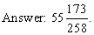
Example 2: Solve.
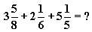
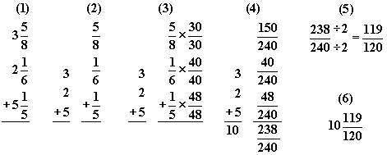
Step 1: Rewrite the problem vertically.
Step 2: Separate the problem into addition of whole numbers and addition of fractions.
Step 3: Find a common denominator for the fractions. For this problem, the common denominator is 240 because 8 x 6 x 5 = 240. Multiply 5/8 by 30/30 (multiply by 30/30 because 8 x 30 = 240). Multiply 1/6 by 40/40. Multiply 1/5 by 48/48.
Step 4: Add the whole numbers (3 + 2 + 5 = 10). Add the numerators (150 + 40 + 48 = 238). The denominator remains the same (240).
Step 5: Since 238 and 240 can both be divided by 2, the fraction 238/240 can be reduced to 119/120.
Step 6: Combine the whole number and the fraction to produce the answer.
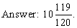

Subtract Decimals: Millionths
Subtracting decimal numbers with more than three decimals requires a strong understanding of the subtraction process, specifically regrouping (trading or borrowing).

The following is a step-by-step example of subtracting two decimal numbers.
Example 1: Solve. 5.345283 - 2.923101= ?
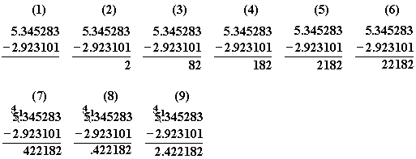
Step 1: Rewrite the problem vertically. Always line up the decimal points.
Step 2: Begin by subtracting the millionths column (3 - 1 = 2). Write the 2 in the millionths column.
Step 3: Subtract the hundred-thousandths column (8 - 0 = 8). Write the 8 in the hundred thousandths column.
Step 4: Subtract the ten thousandths column (2 - 1 = 1). Write the 1 in the ten thousandths column.
Step 5: Subtract the thousandths column(5 - 3 = 2). Write the 2 in the thousandths position.
Step 6: Subtract the hundredths (4 - 2 = 2). Write the 2 in the hundredths position.
Step 7: Subtract the tenths. Regrouping must be used because 9 cannot be subtracted from 3. Borrow 1 one from the next column (left of the decimal point), changing the 5 to a 4. Give the 1 to the tenths column, creating 13. Subtract 9 from 13 (13 - 9 = 4). Write 4 in the tenths position.
Step 8: Bring the decimal point straight down and place.
Step 9: Complete the subtraction of the ones (4 - 2 = 2). Write 2 in the ones position.
Answer: 5.345283 - 2.923101 = 2.422182.

Compare Products of +/- Fractions
In this study guide students will learn how to compare the products of positive and negative fractions. First, it is important to review the concept of multiplying fractions.
The following is a step-by-step example of multiplying two fractions.

Example 1: Multiply. Reduce the answer to lowest terms.
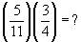
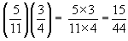
Solution: Multiply the numerators (the number on the top of the fraction) (53 = 15) and the denominators (the number on the bottom of the fraction) (114 = 44).
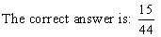
It may be necessary to reduce a fraction that is part of an answer. A fraction is in lowest terms when the numerator and denominator do not have a common factor greater than one. To reduce a fraction, determine the largest number that the numerator and the denominator can both be divided by and divide them by that number.
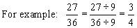
Multiplying positive and negative fractions:
Recall the rules for multiplying positive and negative numbers:
( - ) times ( - ) = + product
( - ) times ( + ) = - product
( + ) times ( - ) = - product
( + ) times ( + ) = + product
These rules apply for the multiplication of positive and negative integers, decimals, or fractions.
The following is a step-by-step example of multiplying two negative fractions.
Example 2: Multiply. Reduce the answer to lowest terms.
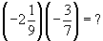
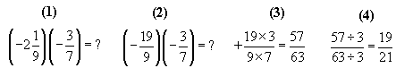
Step 1: Write the problem.
Step 2: Convert the mixed number into an improper fraction. Remember, to change a mixed number into a fraction, multiply the denominator by the whole number and then add the numerator. (92) + 1 = 19. The denominator remains the same. It is usually easiest to ignore the positive and negative signs when completing this step.
Step 3: Before multiplying, the student should determine whether the final answer will be positive or negative. Since we are multiplying two negative numbers, the result will be a positive value. Next, multiply the numerators and the denominators.
Step 4: Reduce the answer to lowest terms. Since 3 is the largest number that 57 and 63 are divisible by, divide the numerator and denominator by 3.
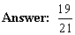
It is necessary to verify that the student understands the values of positive and negative fractions by having him or her create a number line. Label points to the left of 0 negative, and points to the right of the 0 positive. Place several fractions along the number line. The following is an example of a number line that includes positive and negative fractions:
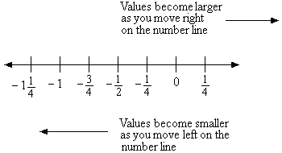
Understanding the values of negative fractions can be a difficult concept for students to master. Students should try to mentally see where negative fractions fall on the number line and remember that the farther to the left of 0 the number is, the smaller the value.
Comparing fractions usually involves ordering numbers using ordering symbols. The following list provides the definitions for the commonly used ordering symbols.
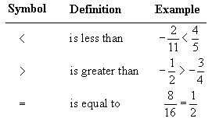
Example 3: Compare. Use <, >, or =.
Solution:
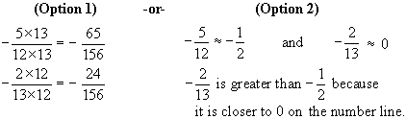
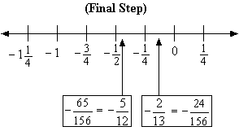
Option 1: When comparing positive and negative fractions, the student has two choices. First, the student can find a common denominator for both fractions. In this case, multiply the numerator and denominator of one fraction, by the denominator of the other fraction. This will create two fractions with the same denominator that are easier for the student to compare. Perform the same steps on the second fraction. Then compare the numerators.
Option 2: If the student prefers to use mental estimation, he or she can realize that since half of 12 is 6, -5/12 is almost equal to -1/2. 2/13 is much less than 1/2 (since 6.5 is half of 13), so -2/13 is actually going to be closer to 0 on the number line.
Final Step: Place or visualize the values on the number line.
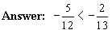
Comparing the Products of Positive and Negative Fractions:
Example 4: Compare. Use <, >, or =.
Solution:
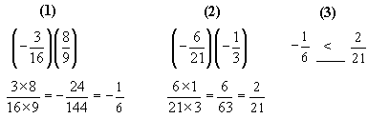
Step 1: Multiply the fractions on the left to determine their product and reduce to lowest terms. Remember, a negative fraction times a positive fraction yields a negative number.
Step 2: Multiply the fractions on the right to determine their product and reduce to lowest terms. Remember, a negative fraction times a negative fraction yields a positive number.
Step 3: Compare the two products. Since positive numbers are always greater in value than negative numbers, there is no need to determine a common denominator.
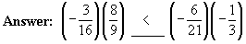
The most important part of mastering this skill is having a firm understanding of the values of negative fractions. Cut off the blank number line below and create a list of several negative fractions for the student. Make sure to widely vary the numerators and denominators. Have the student mark the approximate location of each fraction on the number line. Then, have the student examine the order that the fractions fall on the number line.
------------------------------------------------------------------------------------------------------------
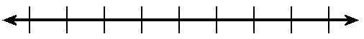

Absolute Value: Simplify
The absolute value of any number is its distance from zero on a number line. Absolute value is always a positive value because it represents a distance.

•The absolute value of -3 (written |- 3|) is 3, since it is 3 units away from zero.
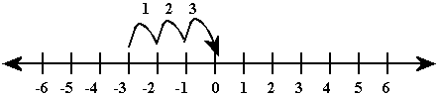
•The absolute value of 4 (written |4|) is 4, since it is 4 units from zero.
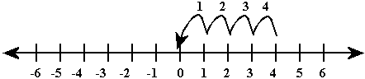
The absolute value of a number is denoted with the following sign or symbol, | |. It works as a grouping symbol and therefore falls in the category of parentheses for order of operations. To evaluate an absolute value expression, perform the calculations inside the absolute value sign first, then take the positive value and "drop" the absolute value sign. Continue calculations using order of operations. For this skill, the result should be numeric.
A review of order of operations is provided below.
P = Parenthesis, E = Exponents, M = Multiplication, D = Division, A = Addition, S = Subtraction.
**Note: Evaluate multiplication and division from left to right (whichever comes first). Evaluate addition and subtraction from left to right (whichever comes first).
Simplifying Absolute Value Expressions
Example 1: Simplify.
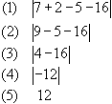
Step 1: Follow order of operations by multiplying first.
Step 2: Addition and subtraction are the remaining operations so perform the calculations from left to right. 7 + 2 = 9.
Step 3: Subtract 9 - 5 = 4.
Step 4: Subtract 4 - 16 = -12.
Step 5: Take the absolute value of -12 which is 12.
Answer: 12
Example 2: Simplify.
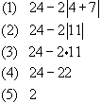
Step 1: Start inside the absolute value sign. Divide first. 8 ÷ 2 = 4.
Step 2: Add. 4 + 7 = 11
Step 3: The absolute value of 11 is 11.
Step 4: Multiply. 2 11 = 22
Step 5: Subtract. 24 - 22 = 2.
Answer: 2
A good way to reinforce the concept of absolute value is to ask the student if he or she is able to think of how and when absolute values are used in everyday life (temperature, elevation, time A. D. or B. C., etc.).

Order of Operations with Fractions - A
A fraction consists of two parts: the numerator and the denominator. The numerator is the top number and the denominator is the bottom number. The order of operations is just what it sounds like: the order in which one computes operations in an expression.

Here is the order of operations:
(1) Parentheses, Brackets, and Braces
(2) Exponents or Roots
(3) Multiply or Divide in order from left to right
(4) Add or Subtract in order from left to right
The order of operations is the same whether you are working with whole numbers, fractions, or decimals. Here are a few helpful hints for using the order of operations. First, remember to complete all operations of one type before moving on to the next type (for example, complete all multiplication and division before moving on to addition or subtraction). Second, remember that when working the multiplication or division move from the left to the right. (For example, 2 x 6 ÷ 3. In this case, you would multiply 2 and 6, then divide by 3.) Finally, addition and subtraction work the same way as multiplication and division - from the left to the right. (For example, 10 - 6 + 2. In this case, you would subtract 6 from 10 first, then add the 2.) Now we are ready for an example.
Example 1: Reduce the answer to lowest terms.
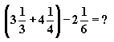
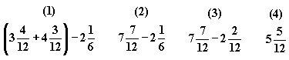
Step 1: Following the order of operations, 3 1/3 + 4 1/4 must be completed first because it is in parentheses. Before two fractions can be added, a common denominator must be determined. The simplest method for determining a common denominator is to multiply the denominators of the fractions. In this case, the common denominator is 12, 3 x 4 = 12. Multiply 1/3 by 4/4 to get the fraction 4/12. Multiply 1/4 by 3/3 to get the fraction 3/12.
Step 2: Add the whole numbers (3 + 4 = 7). Add the numerators of the fractions (4 + 3 = 7). The denominator remains the same (12). 3 4/12 + 4 3/12 = 7 7/12, so the problem is now 7 7/12 - 2 1/6.
Step 3: Before these two fractions can be subtracted, a common denominator must be determined. The common denominator is 12 because 12 and 6 will both divide into 12 without any remainders. Multiply 1/6 by 2/2 to get the fraction 2/12. It is not necessary to multiply 7/12 by any number because it already has the common denominator of 12.
Step 4: Subtract the whole numbers (7 - 2 = 5). Subtract the numerators (7 - 2 = 5). The denominator remains the same (12).
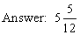
Example 2: Reduce the answer to lowest terms.
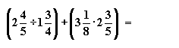
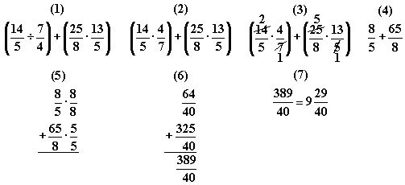
Step 1: The order of operations states that operations in parentheses must be completed first. In the first set of parentheses (the one on the left), we need to divide two mixed numbers, so we must rewrite the two mixed numbers as fractions. To rewrite a mixed number as an improper fraction, first multiply the whole number by the denominator (2 x 5 = 10), then add the numerator to that product (10 + 4 = 14), so 2 4/5 = 14/5 and 1 3/4 = 7/4. We need to rewrite the mixed numbers in the second set of parentheses as improper fractions also, 3 1/8 = 25/8 and 2 3/5 = 13/5.
Step 2: We still need to divide the two improper fractions in the first set of parentheses. Here is an easy rhyme to help you remember how to divide fractions: "Dividing fractions is easy as pie, flip the second and multiply." When 7/4 is "flipped" (inverted) it becomes 4/7. Now that 7/4 has been inverted, we are multiplying 14/5 by 4/7.
Step 3: If a numerator and a denominator share a common factor, those numbers can be simplified before multiplying the fractions. Reminder: This only works when MULTIPLYING fractions! Take, for instance, the numerator of 14 and the denominator of 7 in the first set of parentheses. These two numbers share a common factor of 7 (7 = 7 x 1 and 14 = 7 x 2), so the 7 and the 14 can both be divided by 7. The 7 gets crossed out and becomes a 1 while the 14 gets crossed out and becomes a 2. The same rule applies to the denominator of 5 and numerator of 25 in the second set of parentheses.
Step 4: In the first set of parentheses, multiply the numerators (2 x 4 = 8) and multiply the denominators (5 x 1 = 5). 2/5 x 4/1 = 8/5. In the second set of parentheses, multiply the numerators (5 x 13 = 65) and multiply the denominators (8 x 1 = 8). 5/8 x 13/1 = 65/8.
Step 5: Write the horizontal addition problem vertically. To add the two fractions, a common denominator must be determined. In this case, the common denominator is 40 (8 x 5 = 40). Multiply 8/5 by 8/8 to get the fraction 64/40. Multiply 65/8 by 5/5 to get the fraction 325/40.
Step 6: Add the numerators (64 + 325 = 389). The denominator remains the same (40).
Step 7: Since 389/40 is an improper fraction, it can be written as a mixed number. The number 40 will divide into 389 nine times with 29 left over, so 389/40 can be written 9 29/40.
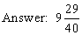

Order of Operations with Fractions - B
The order of operations is the order in which operations within an expression are performed.

Here is the order of operations:
(1) Parentheses, Brackets, and Braces
(2) Exponents or Roots
(3) Multiply or Divide in order from left to right
(4) Add or Subtract in order from left to right
The order of operations is the same whether you are working with whole numbers, fractions, or decimals. Here are a few helpful hints for using the order of operations. First, remember to complete all operations of one type before moving on to the next type (for example, complete all multiplication and division before moving on to addition or subtraction). Second, remember that when working the multiplication or division move from the left to the right. (For example, 2 x 6 ÷ 3. In this case, you would multiply 2 and 6, then divide by 3.) Finally, addition and subtraction work the same way as multiplication and division - from the left to the right. (For example, 10 - 6 + 2. In this case, you would subtract 6 from 10 first, then add the 2.)
Example 1: Reduce answer to lowest terms.
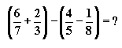
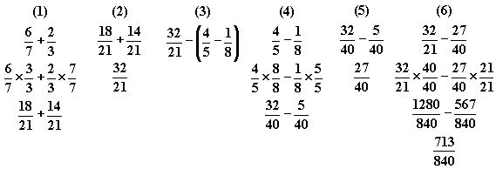
Step 1: Since the problem has two sets of parentheses, complete the operations in the first set of parentheses (from left to right) first. Add 6/7 and 2/3. Find a common denominator (a number that is a multiple of both denominators). The lowest common denominator is 21. Multiply 6/7 by 3/3 to get 18/21. Multiply 2/3 by 7/7 to get 14/21.
Step 2: Add the numerators (18 + 14 = 32). The denominator (21) remains the same.
Step 3: Rewrite the problem with 32/21 in place of the first set of parentheses.
Step 4: Now, evaluate the second set of parentheses. Find a common denominator for 4/5 and 1/8. The lowest common denominator is 40. Multiply 4/5 by 8/8 to get 32/40. Multiply 1/8 by 5/5 to get 5/40.
Step 5: Subtract the numerators (32 - 5 = 27). The denominator (40) remains the same.
Step 6: Rewrite the problem with 27/40 in place of the second set of parentheses. Determine a common denominator. The lowest common denominator is 840 (21 x 40 = 840). Multiply 32/21 by 40/40 to get 1280/840. Multiply 27/40 by 21/21 to get 567/840. Subtract the numerators (1280 - 567 = 713). The denominator (840) remains the same. The fraction cannot be reduced.
Example 2: Reduce the answer to lowest terms.
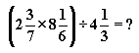
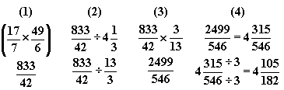
Step 1: Complete the operations in the parentheses first. Rewrite all mixed fractions as improper fractions by multiplying the denominator by the whole number and adding the numerator to that total. This number is now the numerator of the fraction and the denominator is the same as before. 2 3/7 becomes 17/7. 8 1/6 becomes 49/6. Multiply the numerators (17 x 49 = 833). Multiply the denominators (7 x 6 = 42).
Step 2: Rewrite the problem with the fraction 833/42 in place of the set of parentheses. Rewrite the mixed number 4 1/3 as an improper fraction (13/3).
Step 3: Rewrite the division problem as a multiplication problem by inverting the second fraction. 13/3 becomes 3/13 and the problem is now a multiplication problem. Multiply the numerators (833 x 3 = 2499). Multiply the denominators (42 x 13 = 546).
Step 4: Rewrite the improper fraction as a mixed number. 546 will divide into 2499 4 times with 315 left over, so 2499/546 becomes 4 315/546. Reduce the fraction to lowest terms. 315 and 546 can both be divided by 3. Complete the division to reduce the fraction to lowest terms.
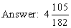

Story Problems: Fractions
Story problems, also called word problems, present addition, subtraction, multiplication, and division problems in text format. Operational symbols, such as the subtraction (-) symbol, are replaced with text. Students are required to read passages, determine the question being asked, identify the elements needed to solve the problem, decide on the correct operation or operations (addition, subtraction, multiplication, division), and find a solution.

Story problems are often very difficult for students to master. It may be beneficial for you to confirm that the student is comfortable with addition, subtraction, multiplication, and division skills. Then, create equations that relate to his or her daily activities, such as sports or music lessons. Help the student determine the correct formulas.
Example 1:
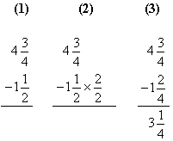
Step 1: Determine that subtraction is required to solve the problem and write the equation needed. Since Kevin started with 4 3/4 gallons and 1 1/2 gallons have been drunk, the equation will be 4 3/4 - 1 1/2. Many students find it easier to subtract mixed numbers when the problem is written vertically as opposed to horizontally.
Step 2: Rewrite the problem as subtraction of whole numbers and subtraction of fractions.
Step 3: Find a common denominator (a common multiple of the denominators of two or more fractions) for the two fractions. For this problem, a common denominator is 4 (because 2 and 4 will both divide into 4). 3/4 does not need to be rewritten because it already has the common denominator (4). Multiply 1/2 by 2/2 to get 2/4.
Step 4: Rewrite the problem with the fractions having common denominators. Subtract the whole numbers (4 - 1 = 3). Subtract the numerators of the fractions (3 - 2 = 1). The denominator (4) remains the same.
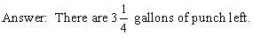
Example 2:
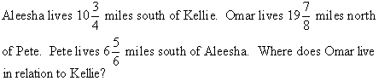
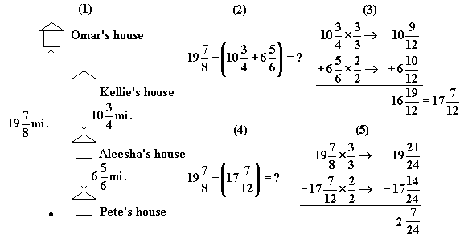
Step 1: Draw a rough sketch of the problem.
Step 2: Determine the operations necessary to solve the problem and write the equation. Since Omar lives north of Kellie, subtract the distance from Kellie's house to Pete's house from the distance between Pete's house and Omar's house (19 7/8). The distance from Kellie's house to Pete's house can be represented by (10 3/4 + 6 5/6). This expression is placed in parentheses because the sum must be determined before subtracting.
Step 3: Using the order of operations, add the mixed numbers in the parentheses first. Determine a common denominator. In this problem, the lowest common denominator is 12 (12 is the lowest common multiple of 4 and 6). Multiply 3/4 by 3/3 to get 9/12. Multiply 5/6 by 2/2 to get 10/12. Add the whole numbers (10 + 6 = 16). Add the numerators of the fractions (9 + 10 = 19). The denominator (12) remains the same. The fraction 19/12 can be reduced to 1 7/12. Add the 1 to the 16 to get 17. The new mixed number is 17 7/12.
Step 4: Rewrite the original equation with the new mixed number.
Step 5: Many students find it easier to add and subtract mixed numbers when the problem is written vertically. Determine a common denominator for the two fractions. In this problem, the lowest common denominator is 24 (24 is the lowest common multiple of 8 and 12). Multiply 7/8 by 3/3 to get 21/24. Multiply 7/12 by 2/2 to get 14/24. Subtract the whole numbers (19 - 17 = 2). Subtract the numerators of the fractions (21 - 14 = 7). The denominator (24) remains the same. The fraction cannot be reduced.
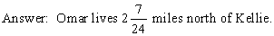
Example 3:
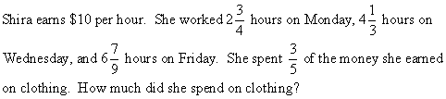
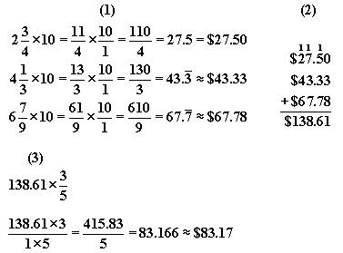
Step 1: Multiply the number of hours worked each day by the amount of money Shira earns per hour. To multiply a mixed number by a whole number, first rewrite the mixed fraction as an improper fraction. For example, to change 2 3/4 into an improper fraction, multiply the denominator by the whole number (4 x 2 = 8). Then add that product and the numerator (8 + 3 = 11). The denominator remains the same and 2 3/4 can be written as 11/4. The next step in multiplying a mixed number by a whole number is to write the whole number as a fraction by placing a 1 in the denominator. Now, multiply the numerators (11 x 10 = 110) and the denominators (4 x 1 = 4). Since this problem is discussing money, we need to turn the fraction into terms of money. This can be accomplished by dividing the numerator by the denominator (110 ÷ 4 = 27.5). Now round to the nearest cent (hundredth) if necessary and place a dollar sign in front of the dollar amount.
Monday: $27.50
Wednesday: $43.33
Friday: $67.78
Step 2: Determine the total amount of money earned by adding the amount earned on Monday, Wednesday, and Friday ($27.50 + $43.33 + $67.78 = $138.61).
Step 3: Determine the amount of money spent on the clothing by multiplying the total amount of money earned by the fraction of the money spent on the clothing. Multiply the numerators (138.61 x 3 = 415.83). Multiply the denominators (1 x 5 = 5). To turn the problem back into money, divide 415.83 by 5 to get 83.166. Round 83.166 to the nearest cent (hundredth) and place a dollar sign in front of the dollar amount.

Reciprocals
Understanding fractions involves identifying lowest common denominators, reciprocals, lowest terms, and equivalent fractions.

Reciprocals are two numbers whose product is equal to 1. For example, 2/3 and 3/2 are reciprocals because
2/3 x 3/2 = 1. 1/4 and 4 are also reciprocals because 1/4 x 4/1 = 1.
A fraction is written in lowest terms when the numerator and the denominator have no common factor greater than 1. The fraction 6/24 is not reduced to lowest terms because 6 is a common multiple of both 6 and 24. 6/24 can be reduced to 1/4 by dividing 6 into 6 and 6 into 24. 1/4 is a fraction written in lowest terms because 1 and 4 have no common multiple greater than 1.
Example:
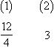
Step 1: Flip 4/12 to get 12/4.
Step 2: Simplify 12/4 to get 3.
As the student practices fraction skills, remind him or her that fractions represent portions or parts and that for every fraction, there is a corresponding portion. The fraction 1/2 communicates a specific portion of something, but this specific portion can also be communicated by the fractions 2/4, 3/6, 8/16, 10/20, etc. All of these fractions are equal to 1/2 because the relationship between the numerator and denominator in 1/2 is the same relationship between the numerators and denominators in 2/4, 3/6, 8/16, and 10/20. This relationship is shown in that each fraction can be reduced to 1/2. In other words, if you have eaten 8/16 of a pizza, you have eaten 1/2 of the pizza.

Calculating Percentages
Percent is a way to express a number as it compares to 100. Percent means "per one hundred." If 7 out of 100 students ate pizza for lunch, then 7% of the students ate pizza for lunch.

Ask the student how he or she would calculate the percentage of students who ate tacos for dinner if he or she knew that 35 out of 50 students had eaten tacos for dinner. Remind him or her that percent is "per one hundred." He or she should first set up the ratios: 35/50 =?/100. 50 multiplied by 2 is 100, so 35 should be multiplied by 2 to make the ratios equal. The result is 70/100 which translates into 70%. 70% of the students ate tacos for dinner.
The student should also understand how to determine the percent of a given number.
Example 1: Find 25% of 48.
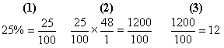
Step 1: Change the percent amount to a fraction (remember percent means "per one hundred").
Step 2: Multiply 25/100 by 48. Change 48 into a fraction by making its denominator 1. Multiply numerator by numerator (25 x 48 = 1200). Multiply denominator by denominator (100 x 1 = 100).
Step 3: Reduce the product to its lowest terms (1200 ÷ 100 = 12).
Answer: 12
The student should also understand how to determine the percent one number is of another.
Example 2: What percent of 45 is 36?
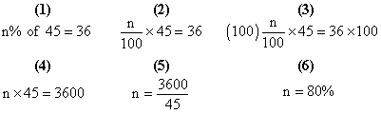
Step 1: Rewrite the equation. Since the percent is what we want to find, we can represent it with the variable n%.
Step 2: Change n% to a fraction and multiply it by 45. n% times 45 should equal 36. Write the new equation.
Step 3: Multiply both sides of the equation by 100 to begin to isolate the n on one side of the equal sign.
Step 4: Rewrite the equation with the new numbers.
Step 5: Divide both sides of the equation by 45.
Step 6: 3,600 ÷ 45 = 80.
Answer: 80%
The student should also understand percent increase and percent decrease. Percent of decrease tells the percent the original amount has decreased. To determine the percent of decrease we use the following formula:
percent of decrease = (amount of decrease ÷ original amount) x 100
Example 3: Find the percent of decrease if the original amount is $20 and the new amount is $19.
(1) $20 - $19 = $1
(2) $1 ÷ $20 = 0.05
(3) 0.05 x 100 = 5%
Step 1: Determine the amount of decrease by subtracting the original amount from the new amount. The amount of decrease is 20 - 19 = 1.
Step 2: Divide the amount of decrease by the original amount (1 ÷ 20 = 0.05).
Step 3: Change 0.05 to a percent. This can be accomplished by multiplying 0.05 by 100. (Another way to convert a decimal number to a percent is to move the decimal point two places to the right.)
Answer: 5%
Percent of increase tells the percent the original amount has increased. To determine the percent of increase we use the following formula:
percent of increase = (amount of increase ÷ original amount) x 100
Example 4: Find the percent of increase if the original amount is $6 and the new amount is $9.
(1) $9 - $6 = $3
(2) $3 ÷ $6 = 0.50
(3) 0.50 x 100 = 50%
Step 1: Determine the amount of increase by subtracting the original amount from the new amount
($9 - $6). The amount of increase is $3.
Step 2: Divide the amount of increase by the original amount to determine the percent of increase.
Step 3: Change 0.50 to a percent. This can be accomplished by multiplying 0.50 by 100. The simple way to convert a decimal number to a percent is to move the decimal point two places to the right.
Answer: 50%

Rounding and Estimation - F
Rounding and estimation are used to express numbers to the nearest tenth, hundredth, thousandth and so forth. Real world applications use rounding and estimation to make numbers more manageable and understandable. For example, television producers often round large numbers so that reporters can state them in a simple manner. If the United States produced 134,995,659 ounces of gold, a reporter might state, "The United States' gold production this year was 135,000,000 ounces."

One interesting method for improving the student's rounding and estimation skills is to create a list of numbers. Help the student round each number. Remember to look to the right of the place value you wish to round. Numbers less than 5 are rounded down, while numbers 5 or greater are rounded up.
34 rounded to the nearest ten is 30.
37 rounded to the nearest ten is 40.
To help the student round decimal numbers, review decimal places with him or her. For example, in the number 6,879.342
6 = thousands
8 = hundreds
7 = tens
9 = ones
3 = tenths
4 = hundredths
2 = thousandths
Once the student understands decimal places, ask him or her to round 6,879.342 to the nearest tenth. Look at the first digit to the right of the tenths place. The hundredths place is less than 5, so the tenths place remains unchanged. 6,879.342 rounded to the tenths place is 6,879.3
Estimation is also an important skill for simplifying and managing large numbers. For example, what is the estimated value of 37 x 11? Round each of the whole numbers to the tens place. 37 to 40 and 11 to 10. Think 40 x 10 = 400. Therefore, the estimated value of 37 x 11 is 400.
Example 1: What is the estimated sum when 510 and 76 are rounded to the nearest hundred and added?
A. 400
B. 600
C. 500
D. 700
Solution: To solve this problem, we round 510 to 500 and 76 to 100. Then, add 500 + 100 = 600. The answer is 600.
Example 2: What is the estimated quotient when 81.49 is divided by 8.976 to the nearest whole number?
Answer: Round 81.49 to 81 and 8.976 to 9. 81÷ 9 = 9

