Study Guide
8th Grade Measurement Review
05/18/2016

Area of Parallelogram - C
A parallelogram is a quadrilateral (a four-sided figure) with two pairs of parallel and congruent sides. Area is the measure, in square units, of the interior region of a two-dimensional figure.

To find the area of a parallelogram, multiply the base(b) by the height(h). The base is the length of either the top or bottom. The height is the length of a line going from the base at a right angle to the opposite side. Here is the formula:
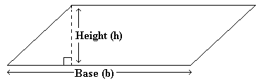
Area of a parallelogram = (base) x (height)
Example 1: Find the area of a parallelogram with a base equal to 5 feet and a height equal to 2 feet?
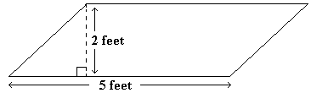
Area = 5 feet x 2 feet = 10 square feet
Answer: 10 square feet
Example 2: Find the area of a parallelogram with a base equal to 5 meters and a height equal to 6 meters?
Area = 5 meters x 6 meters = 30 square meters
Answer: 30 square meters

Surface Area of a Pyramid
A pyramid is a three-dimensional figure whose base is a polygon and whose other faces are triangles that share a common vertex. Surface area is the total area of the faces (including bases) of a three-dimensional figure.

To find the surface area of a pyramid, you need to find the area of the base and the area of the sides and add them up. It may be helpful to visualize the parts of a square pyramid and the parts of a triangular pyramid:
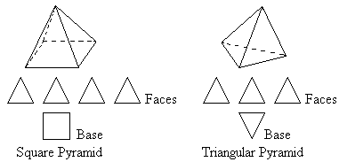
To find the area of a square with side length b, use the following formula.
Area of a square = length x length = b x b
If the area of the square is already known, the length of a side can be found by taking the square root of the area.
To find the area of a triangle, use the following formula.
Area of a triangle = 1/2 x (base) x (height)
Example 1: Find the surface area of a pyramid with a square base with sides 8 ft long and the height of each triangular face is 7 ft long.
(1) 8 x 8 = 64 square feet
(2) (1/2) (8 feet) (7 feet) = 28 square feet
(3) 64 + 28 + 28 + 28 + 28 = 176 square feet
Step 1: Determine the area of the base. The base of this pyramid is a square. The side length is 8 feet, so multiply 8 x 8 to get the area of base. The area of the base is 64 square feet.
Step 2: Determine the surface area of one of the triangular faces. The sides of the base are 8 ft long, so the base of the triangular face is 8 ft long. The height is given as 7 ft. Substitute the values of the base and height into the formula for the area of a triangle to get the area of one triangular face.
Step 3: Add the areas of all faces (including the base) together. There is one base and four faces.
Total surface area = 64 + 28 + 28 + 28 + 28 = 176 square feet.
We can similarly determine the area of a triangular pyramid if all faces including the base are congruent. If we are given the surface area of one of the faces, we can multiply that times the number of faces (4) to determine the total surface area for the pyramid.
Example 2: The area of one face of a triangular pyramid is 32 square centimeters. All of the faces, including the base are congruent. What is the surface area of the triangular pyramid?
There are 4 triangles in a triangular pyramid, so multiply 32 x 4 to get the surface area of the pyramid.
32 x 4 = 128
The surface area of the triangular pyramid is 128 square centimeters.
When given the length of the sides of the base and the height of each face, you can determine the surface area of one face and multiply that number by 4 (the number of faces), when the base and faces are congruent.

Story Problem: Measurement Procedures
Measurement procedures and formulas are often used in real world situations. Finding the area of a floor that needs new carpet or the volume of a box to be filled are just a couple of examples. Students should understand how to apply measurement procedures as well as area, circumference, and volume formulas to solve story problems.

Real world problems are often difficult for students to master. It may be beneficial to confirm that the student is comfortable with measurement procedures and formulas outside of a real world context. Begin by reviewing the definitions and calculation procedures for determining area, circumference, and volume with the student.
Area is the measurement of the interior of a two-dimensional region and is measured in square units. The formulas used to find the area of a rectangle, a triangle, and a circle are shown below.
Area of a rectangle = length width, or A = lw.
A square is a rectangle with four equal sides, so the formula for the area of a square is often shown as Area of a square = side² , or A = s² , because the length is equal to the width for all squares.
Area of a triangle =1/2 base height, or A = (1/2)bh.
The height of a triangle is the length of the line segment that extends from the vertex opposite the base and is perpendicular to the base, as shown below.
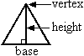
Area of a circle = 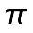 radius² , or A = r² .
The radius of the circle is the length of a line segment from the center of the circle to any point on the circle. The diameter is the length of a line segment from one point on the circle through the center of the circle to another point on the circle. The length of the diameter of a circle is twice the length of the radius of the circle. , or pi, is equal to about 3.14.
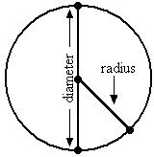
Example 1:
Find the area of a rectangle with a length of 6 cm and a width of 3 cm.
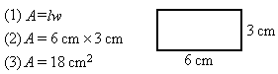
Step 1: Write the formula for the area of a rectangle.
Step 2: Substitute in 6 for the length and 3 for the width.
Step 3: Multiply to get 18.
Answer: The area of the rectangle is 18 cm² .
Example 2:
Find the area of a triangle with a base of 4 feet and a height of 8 feet.
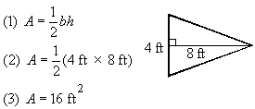
Step 1: Write the formula for the area of a triangle.
Step 3: Substitute 4 for the base and 8 for the height.
Step 3: Multiply to get 16.
Answer: The area of the triangle is 16 ft² .
Example 3:
Find the area of the circle with a radius of 8 cm. Use = 3.14
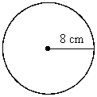
(1) A = r²
(2) A = 3.14(8 cm)²
(3) A = 3.14(64 cm² ) = 200.96 cm²
Step 1: Write the formula for the area of a circle.
Step 2: Substitute 3.14 for and 8 for the radius.
Step 3: Square 8 and multiply by 3.14.
Answer: The area of the circle is 200.96 cm² .
Circumference is the distance around a circle. The formula used to find the circumference is:
Circumference = 2 radius, or C = 2r.
Example 4:
Find the circumference of a circle with a radius of 7 m.
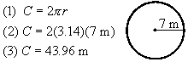
Step 1: Write the formula for circumference.
Step 2: Substitute 3.14 for and 7 for the radius.
Step 3: Multiply to get 43.96.
Answer: The circumference of the circle is 43.96 m.
Volume is the measurement of the interior space of a three-dimensional figure. Volume is measured in cubic units. The formula for calculating the volume of a rectangular solid, like a box, is:
Volume = length width height, or V = lwh.
Example 5:
Find the volume of the rectangular solid with a length of 6 inches, a width of 2 inches, and a height of 4 inches.
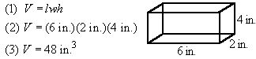
Step 1: Write the formula for volume of a rectangular solid.
Step 3: Substitute in 6 for the length, 2 for the width, and 4 for the height.
Step 3: Multiply to get 48 in.³ .
Answer: The volume of the rectangular solid is 48 in.³ .
Using Measurement Procedures and Formulas Within Real World Problems:
When solving real world problems, clues from the text of the problem must be used to set up the equations. The formulas for area, circumference, and volume are often necessary to set up these equations and solve the story problems.
Example 6:
Alyssa is building a doghouse for her puppy. She wants the floor of the doghouse to be rectangular with a length of 3 feet and a width of 2 feet. To buy the correct amount of material for the doghouse, she needs to know the area of the floor. What is the area of the doghouse floor?
(1) A = lw
(2) A = (3 ft)(2 ft)
(3) A = 6 ft² .
Step 1: The floor of the doghouse is a rectangle, so the formula for the area of a rectangle is needed.
Step 2: Substitute in 3 for the length and 2 for the width.
Step 3: Multiply to get 6.
Answer: The area of the doghouse floor is 6 ft² .
Sometimes, a dimension other than the area is unknown in a problem. Examples of these types of problems are provided below.
Example 7:
Find the height of a triangular sail with an area of 60 m² and a base of 8 m.
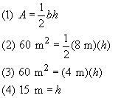
Step 1: Begin with the formula for the area of a triangle.
Step 2: Substitute in 60 for the area and 8 for the base.
Step 3: Simplify the equation by multiplying 1/2 and 8 to get 4.
Step 4: Isolate the height by dividing each side of the equation by 4.
Answer: The height of the sail is 15 m.
Example 8:
The workers need to determine if their tool is going to fit through the circular manhole they are working in this week. They know that the area of the manhole is 8 ft² . What is the diameter? Use = 3.14 and round your answer to the nearest tenth, if necessary.
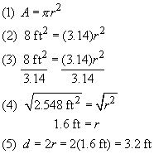
Step 1: Begin with the formula for the area of a circle.
Step 2: Substitute in 8 ft² for the area and 3.14 for .
Step 3: Simplify the equation by dividing both sides by 3.14.
Step 4: Solve for the radius by taking the square root of each side of the equation.
Step 5: Multiply the radius by 2 to find the diameter of the manhole.
Answer: The diameter of the manhole is 3.2 ft.
To better understand how to use measurement procedures and formulas in story problems, have students determine the area of a square drink coaster, a rectangular table top, and a triangular piece of pie. They can also determine the circumference of a plate and the volume of a facial tissue box.

Units of Measurement - D
Students are given questions pertaining to units of length, weight, mass, and capacity for both the U.S. Standard (Customary) and the Metric System.

The following shows the relationship between the Customary Units of measure:
12 inches = 1 foot
3 feet = 1 yard
36 inches = 1 yard
5280 feet = 1 mile
1760 yards = 1 mile
4 quarts = 1 gallon
2 pints = 1 quart
2 cups = 1 pint
4 cups = 1 quart
16 ounces = 1 pound
The following shows the relationship between the Metric Units of length:
10 millimeters = 1 centimeter
100 millimeters = 1 decimeter
1000 millimeters = 1 meter
10 centimeters = 1 decimeter
100 centimeters = 1 meter
1000 meters = 1 kilometer
100 meters = 1 hectometer
10 meters = 1 dekameter
Example 1: A table is 36 inches tall. How tall is the table in feet?
Solution: There are 12 inches in 1 foot. Divide 36 by 12, the result is 3.
Answer: 3 feet
The student should also practice adding and subtracting different units of measurement.
Example 2: Solve.
2 ft 7 in
- 10 in
(1) 1 ft 19 in
- 10 in
(2) 1 ft 9 in
Step 1: Borrow 1 ft (12 in) from the 2 feet, making the 2 a 1. Make the 7 a 19 (7 + 12 = 19).
Step 2: Subtract. 1 ft - 0 ft = 1 ft and 19 in - 10 in = 9 in
Answer: 9 in

Temperature - D
Celsius is the unit used in the metric system for measuring temperature.

The mean temperature is the average of the known temperatures. To find the mean or average temperature, add together all known temperatures and divide the sum by the amount of numbers added together.
Example 1: In August, the high temperature was 36º C. The low temperature was 28º C.
What was the mean temperature for the month of August?
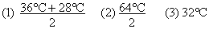
Step 1: Since we know the high temperature and the low temperature, we add them together (36º C + 28º C). Since we added two numbers together, we must divide the sum of the temperatures by 2.
Step 2: 36º C + 28º C = 64º C
Step 3: Divide 64º C by 2 to get the mean temperature of 32º C.
The mean temperature for August was 32º C.
The range is the spread between the low number and the high number. Subtract the low temperature from the high temperature to determine the temperature range.
Range = high value - low value
Example 2: On Thursday, the low temperature was -2º C and the high temperature was 12º C.
What was the temperature range for Thursday?
(1) high temperature = 12º C; low temperature = -2º C
(2) 12º C - (-2º C)
(3) 12º C + 2º C
(4) 14º C
Step 1: Determine the high and low temperatures.
Step 2: Subtract the low temperature (-2º C) from the high temperature (12º C). Don't forget to keep the negative sign with the -2º C.
Step 3: Remember that subtracting a negative number can be rewritten as adding a positive number.
Step 4: Add 12º C and 2º C to get the temperature range.
The temperature range for Thursday was 14º C.

Circumference - B
Circumference is the distance around a circle.

The following is the formula necessary for calculating the circumference of a circle:
Pi is equal to about 3.14. The symbol for pi is
The diameter is a line segment from one point on the circle through the center of the circle to another point on the circle. The radius is a line segment from the center of a circle to a point on the circle. The length of the diameter of a circle is twice the length of the radius of the circle. For example, if a circle has a radius equal to 6 inches, the diameter equals 2 x 6 inches which is 12 inches.
Example 1: What is the circumference of a circle with a diameter of 12 meters?
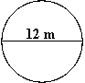
(1) Circumference = 3.14 x 12
(2) Circumference = 37.68m
Step 1: Substitute the value of the diameter into the formula for the circumference of a circle. Remember, pi is equal to about 3.14.
Step 2: Multiply 3.14 by 12 to get the circumference of the circle.
The circumference of the circle is 37.68 m.
Example 2: Joshua Pine High School has an oval track. Use the diagram to find the length of the track.
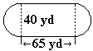
Solution:
The center section of the track (between the two dotted lines) is a rectangle with a length of 65 yards. Each end of the track is a semicircle (half of a circle) with a diameter equal to 40 yards.
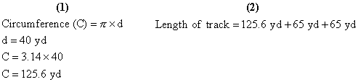
Step 1: Since each end of the track is a semicircle with diameter 40 yd, the two ends can be put together to make a full circle with diameter 40 yd. Finding the circumference of the circle will find the distance around both ends of the track. The circumference of the circle is 125.6 yd.
Step 2: The length of the track is equal to the sum of the distance around the two ends plus the length of the two straight sides. The distance around the two ends is 125.6 yd and the length of each of the two straight sides is 65 yd.
The length of the track is 255.6 yd.

Mass/Capacity - C
Mass is the total amount of matter that a figure contains. Capacity is the liquid content or volume of a figure. Mass and capacity are communicated using the metric system. Mass/capacity problems require students to estimate the mass or capacity of specific amounts and to convert grams to milligrams, metric tons to grams, etc.

Before the student can solve mass and capacity problems, he or she must first understand mass/capacity metric measurements. The gram is the basis of weight measurements in the metric system. Here is a basic breakdown of the metric system of weight.
1,000 milligrams (mg) = 1 gram (g)
100centigrams (cg) = 1 gram (g)
10 decigrams (dg) = 1 gram (g)
1 dekagram (dag) = 10 grams (g)
1 hectogram (hg) = 100 grams (g)
1 kilogram (kg) = 1,000 grams (g)
1 metric ton (t) = 1,000,000 grams
The liter is the basis of capacity measurements in the metric system. Here is a basic breakdown of the metric system of capacity.
1,000 milliliters (ml) = 1 liter (l)
100centiliters (cl) = 1 liter (l)
10 deciliters (dl) = 1 liter (l)
1 dekaliter (dal) = 10 liters (l)
1 hectoliter (hl) = 100 liters (l)
1 kiloliter (kl) = 1,000 liters (l)
When the student understands these conversions, he or she is ready to make estimations. To help the student determine the approximate mass, give him or her objects from around the house to make estimates. A loaf of bread, for instance, probably has a mass of around 500 grams. For capacity questions, use glasses and other containers. Help the student estimate the capacity of liquid in each container.

Length - B
Students are required to convert units of measurement.

The following shows the relationship between the Customary Units of length:
12 inches = 1 foot
3 feet = 1 yard
12 inches = 1 foot
36 inches = 1 yard
5280 feet = 1 mile
1760 yards = 1 mile
The following shows the relationship between the Metric Units of length:
10 millimeters = 1 centimeter
100 millimeters = 1 decimeter
1000 millimeters = 1 meter
10 centimeters = 1 decimeter
100 centimeters = 1 meter
1000 meters = 1 kilometer
100 meters = 1 hectometer
10 meters = 1 dekameter
Example 1: A table is 36 inches tall. There are 12 inches in 1 foot. Divide 36 by 12, the result is 3. The table is 3 feet tall. Continue with other objects and also use the metric system.
Example 2: A fence is 4 meters long. Jim put a gate on the end of the fence that was 20 decimeters long. How long is the fence and the gate combined?
(1) 20 decimeters = 2 meters
(2) 4 meters + 2 meters = ?
Step 1: Convert units to like units.
Step 2: Add the units.
Answer: 6 meters

Time - E
This skill assesses the student's ability to tell time, add hours and minutes, and solve word problems.

The student should be able to add or subtract time from the clock.
Example 1: If the clock is set at 5:15, what time will it be in two hours?
Answer: 7:15
It is important that the student understands the following time conversions:
60 minutes = 1 hour
24 hours = 1 day
7 days = 1 week
52 weeks = 1 year
365 days = 1 year
The student should also be familiar with the distance formula:
distance = rate x time
Example 2: Jen is going to fly her plane to Okinawa, which is 2,000 miles away. Jen's airplane flies at an average speed of 500 miles per hour. How long will it take Jen to fly to Okinawa?
(1) Distance = 2,000 miles; Rate = 500 mph; Time = ?
(2) 2,000 = 500 x Time
(3) 2,000 ÷ 500 = Time
(4) 2,000 ÷ 500 = 4
Step 1: Determine the Distance, Rate, and Time amounts from the problem.
Step 2: Apply the amounts to the formula.
Step 3: Rewrite the problem so that the unknown in on one side of the equation.
Step 4: Perform the calculations.
Answer: It will take Jen 4 hours to fly to Okinawa.
Example 3: Lynn read for 7 hours and 23 minutes. Gretchen read for 6 hours and 52 minutes. How much longer did Lynn spend reading?
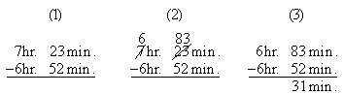
Step 1: Set up the subtraction problem.
Step 2: Since 52 cannot be subtracted from 23, trade one hour in for 60 minutes. Add the 60 minutes to the 23 minutes to get 83 minutes.
Step 3: Subtract.
Answer: 31 minutes

Area of Rectangle - D
The area measurement of a figure refers to the number of square units needed to cover the surface of the figure. Some of the many real world applications for finding the area of figures include household projects, construction work, sewing, and mowing the lawn.

The formula for calculating the area of a square or rectangle is: Area = length x width.
Example 1: A figure has a width of 3 inches and a length of 7 inches. What is the area of the figure?
Step 1: Multiply the width and the length.
Area = 7 x 3 = 21
Answer: 21 square inches
Example 2: What is the value of x?
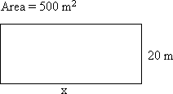
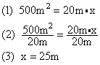
Step 1: The area of a rectangle can be found using the following formula: Area = length x width. The area and width are known, so substitute them into the formula for area.
Step 2: Divide each side of the equation by 20m to isolate the x on one side of the equal sign.
Step 3: 500 divided by 20 equals 25.
Answer: x = 25 m
It may be useful to use graph paper to develop figures. Help the student determine the area of various figures drawn on the graph paper.

Surface Area of a Prism
The surface area of a solid figure is the sum of the areas of all the surfaces. A prism is a polyhedron with parallel bases that are congruent polygons. The other faces of the prism are parallelograms.

To find the surface area of a prism, the student must first find the area of each face. The following is an example of a figure that has six faces.
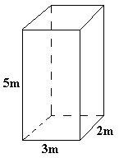 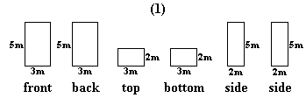
Step 1: Find the area of the six faces:
Area of front = 15 square meters
Area of back = 15 square meters
Area of top = 6 square meters
Area of bottom = 6 square meters
Area of side = 10 square meters
Area of side = 10 square meters
Step 2: Add the areas of the six faces:
15 + 15 + 6 + 6 + 10 + 10 = 62
Answer: 62 square meters

Surface Area of a Cylinder
The surface area of a solid figure is the sum of the areas of all the surfaces. A cylinder is a solid figure with two bases that are circles. A face is one side of a solid figure. When trying to find the surface area of a figure, first find the area of each face, then add those areas together.

Example: Find the surface area of the figure. 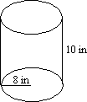
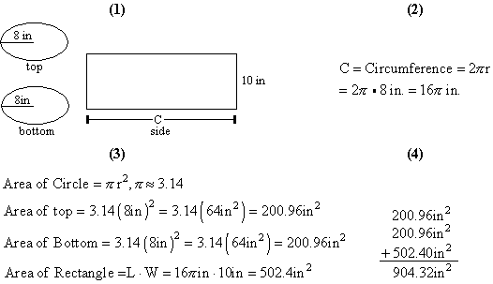
Step 1: Every cylinder has 3 faces: two circles and one rectangle. One way to illustrate this is to roll a rectangular piece of paper into a tube. Each end of the tube is a circle and the tube itself is a rectangle. The top and bottom of the cylinder look like ovals when they are drawn, but they are actually circles. Draw the three faces of the cylinder and label the known parts.
Step 2: The length of the rectangle is not known. It can be found by determining the circumference of the circles. (Circumference is the distance around the circle.) The length of the rectangle is Step 3: Determine the area of each face of the cylinder.
Step 4: Find the sum of the three faces of the cylinder.
The surface area of the cylinder is 904.32 square inches.

Volume of Pyramids
Volume is the measurement of a figure's space. Volume is measured in cubic units. A pyramid is a polyhedron with one base that is a polygon. The other faces of the pyramid are triangles.

The formula for solving the volume of a pyramid is:
Volume = 1/3 (Area of base x height of the pyramid)
Example 1: The length of one side of a pyramid with a square base is 12 cm. The height of the pyramid is 14 cm. What is the volume of the pyramid?
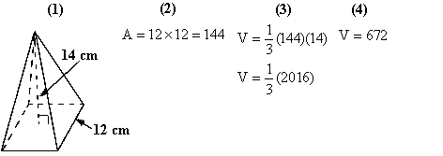
Step 1: Draw and label the pyramid. Remember, it has a square base.
Step 2: Determine the area of the base. The area of a square is found by squaring the length of the side. The area of the base is 12 x 12 = 144 square centimeters.
Step 3: Substitute the area of the base and the height of the pyramid into the formula for the volume of a pyramid. Next, multiply 144 by 14 to get 2016 cubic centimeters.
Step 4: Finally, divide 2016 cubic centimeters by 3.
The volume of the pyramid is 672 cubic centimeters.
It may be helpful to review the following formulas for area of a triangle and area of a rectangle because pyramids also have triangular and rectangular bases.
• 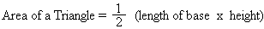
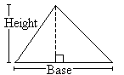
• Area of a rectangle = (length x width)

Volume of Cone
Volume is the measurement of a three-dimensional figure's interior space. Volume is measured in cubic units. A cone is a pyramid-like figure; however, the base is a circle.

The formula for solving the volume of a cone:
Example: Find the volume of a cone with a radius of 3 cm and a height of 10 cm, using 3.14 for pi.
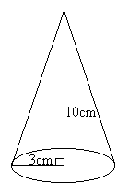
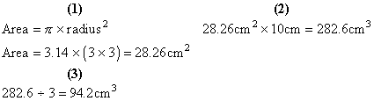
Step 1: Find the area of the base, which is a circle.
Step 2: Multiply the area of the base by the height.
Step 3: Divide the result of Step 2 by 3 (dividing by three is the same as multiplying by 1/3).
Answer: 94.2 cubic centimeters

