Study Guide
7th Grade Measurement Review
05/18/2016

Area of Triangle - B
This skill requires the student to find the area of a triangle, which is one half the area of a rectangle that has the same base and height.
The area of a rectangle can be found by multiplying its base by its height.

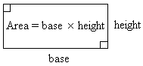
If a rectangle is divided in half along its diagonal, each triangle formed is half the area of the rectangle.
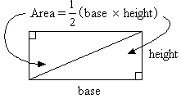
A regular triangle has three 60-degree angles, and sides that are all the same length. The area of a regular triangle is also one half the area of a rectangle with the same base and height.
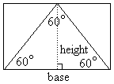
The formula for the area of a triangle is:
Remember: Units for area are always squared. Examples: ft² , in.² , m²
Example 1: What is the area of a triangle if its base is 13 ft and its height is 10 ft?
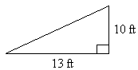
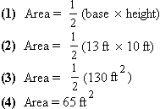
Step 1: Write the formula for the area of a triangle.
Step 2: Substitute 13 ft for the base and 10 ft for the height in the formula.
Step 3: Find the product of 13 ft and 10 ft.
Step 4: Multiply 130 by 1/2 (or divide 130 by 2).
Answer: 65 ft²
Example 2: The side of a hay storage building is in the shape of a triangle. What is the area of the side of the building if its base is 10 ft, its height is 12 ft, and the lengths of the other two sides are 13 ft?
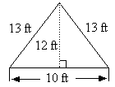
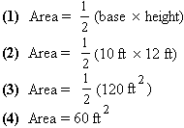
Step 1: Write the formula for the area of a triangle. As you can see from the formula, the lengths of the other two sides, besides the base, are not needed to calculate the area.
Step 2: Substitute 10 ft for the base and 12 ft for the height in the formula.
Step 3: Find the product of 10 ft and 12 ft.
Step 4: Multiply 120 by 1/2.
Answer: 60 ft²
An activity that can help reinforce the concept of area of a triangle is to show students several examples of triangles with the height and lengths of all three sides given. Ask them to write down the equations that would allow them to find the area of each triangle, reminding them that the only two dimensions they need are the height and base.

Accuracy - B
Accuracy and precision in measurement can be extremely important. There are two systems of measurement that are commonly used: the metric system and the U.S. customary (or standard) system.

The Metric System:
The meter is the basis of length measurements in the metric system. Here is a basic breakdown of the metric system of length.
1,000 millimeters (mm) = 1 meter (m)
100centimeters (cm) = 1 meter (m)
10 decimeters (dm) = 1 meter (m)
1 dekameter (dam) = 10 meters (m)
1 hectometer (hm) = 100 meters (m)
1 kilometer (km) = 1,000 meters (m)
The gram is the basis of weight measurements in the metric system. Here is a basic breakdown of the metric system of weight.
1,000 milligrams (mg) = 1 gram (g)
100centigrams (cg) = 1 gram (g)
10 decigrams (dg) = 1 gram (g)
1 dekagram (dag) = 10 grams (g)
1 hectogram (hg) = 100 grams (g)
1 kilogram (kg) = 1,000 grams (g)
The liter is the basis of capacity measurements in the metric system. Here is a basic breakdown of the metric system of capacity.
1,000 milliliters (ml) = 1 liter (l)
100centiliters (cl) = 1 liter (l)
10 deciliters (dl) = 1 liter (l)
1 dekaliter (dal) = 10 liters (l)
1 hectoliter (hl) = 100 liters (l)
1 kiloliter (kl) = 1,000 liters (l)
The U.S. Customary System:
The foot is the basis of length measurements of the U.S. customary system. Here is a basic breakdown of the U.S. customary system of length.
12 inches (in) = 1 foot (ft)
1 yard (yd) = 3 feet (ft)
The pound is the basis of weight measurements of the U.S. customary system. Here is a basic breakdown of the U.S. customary system of weight.
16 ounces (oz) = 1 pound (lb)
1 ton (ton) = 2,000 pounds (lb)
The gallon is the basis of capacity measurements of the U.S. customary system. Here is a basic breakdown of the U.S. customary system of capacity.
16 cups (C) = 1 gallon (gal)
8 pints (pt) = 1 gallon (gal)
4 quarts (qt) = 1 gallon (gal)
Comparing the Two Systems:
Length:
1 inch (in) = 2.54 centimeters (cm)
1 foot (ft) = 0.3048 meters (m)
1 yard (yd) = 0.9144 meters (m)
Weight:
1 ounce (oz) = 28.3495 grams (g)
1 pound (lb) = 453.59 grams (g)
Capacity:
1 cup (C) = 0.2366 liters (l)
1 pint (pt) = 0.4732 liters (l)
1 quart (qt) = 0.9463 liters (l)
1 gallon (gal) = 3.7853 liters (l)
Example 1: Choose the measure that is most precise.
A. 7.22 cm
B. 72 mm
C. 0.072 m
D. They are all of equal precision.
Step 1: It will be easiest to compare the measurements if they are all converted to the same unit.
• Convert 7.22 cm into meters by dividing by 100, since there are 100 cm in 1 meter.
7.22 cm ÷ 100 = 0.0722 m
• Convert 72 mm into meters by dividing by 1,000, since there are 1,000 mm in 1 meter.
72 mm ÷ 1,000 = 0.072 m
Step 2: Compare the three measures.
7.22 cm = 0.0722 m
72 mm = 0.072 m
0.072 m
Solution: Since 7.22 cm is carried out to more decimal places when the measurements are converted to the same unit, it is the most precise.
Answer: A
Example 2: Choose the best estimate for the capacity of a cereal bowl.
A. 2 l
B. 2 oz
C. 2 C
D. 2 gal
Solution:
• 2 liters is 1 large bottle of soda, so it is too large to be the capacity of a cereal bowl.
• 2 ounces are less than one cup, so it is much too small to be the capacity of a cereal bowl.
• 2 cups is less than two liters, but more than 2 ounces, so it is a possible capacity of a cereal bowl.
• 2 gallons is even larger than 2 liters, so it is definitely too large to be the capacity of a cereal bowl.
Answer: C

Convert: Fahrenheit to Celsius
Converting degrees Fahrenheit to degrees Celsius is the process of changing a temperature reading from the U.S. customary system to the metric system. In the customary system, the Fahrenheit scale, water freezes at 32º F and water boils at 212º F. In the metric system, the Celsius scale, water freezes at 0º C and water boils at 100º C. Have the student examine the chart below in order to gain a better understanding of how the two systems relate to one another.

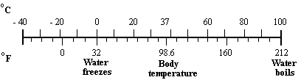
When changing from degrees Fahrenheit to degrees Celsius, it is necessary to use the following formula.
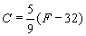
Remembering order of operations, the student will first find the difference of a given Fahrenheit temperature and 32, and then multiply that result by 5/9. This will result in the Celsius temperature.
Example 1: Convert 17º F to º C. Round your answer to the nearest tenth, if necessary.
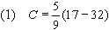
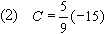
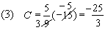
Step 1: Substitute the Fahrenheit value into the conversion formula.
Step 2: Working in the parentheses first, calculate 17 - 32. The result is - 15.
Step 3: Multiply (5/9) and (- 15). Reduce by dividing - 15 and 9 by 3. This will make the multiplication easier. The result is - 25/3.
Step 4: Convert - 25/3 into a decimal by dividing the numerator (- 25) by the denominator (3). The result is - 8.33333 which is equal to - 8.3 repeating. Rounding to the nearest tenth would yield - 8.3.
Answer: - 8.3º C
As an additional activity, place a Fahrenheit thermometer outside where it can easily be seen from the house. Have the student take two readings a day, one in the morning and one at night. Then, have the student convert the temperatures to the Celsius scale. This will allow the student to work with actual measurements and track the weather over a given interval of time. If a thermometer is unavailable, the high and low temperature can be read from the newspaper, television news, or the Internet.

Convert: Celsius to Fahrenheit
Converting degrees Celsius to degrees Fahrenheit is the process of changing a temperature reading from the metric system to the U.S. customary system. In the customary system, the Fahrenheit scale, water freezes at 32º F and water boils at 212º F. In the metric system, the Celsius scale, water freezes at 0º C and water boils at 100º C. Have the student examine the chart below in order to gain a better understanding of how the two systems relate to one another.

The formula for converting degrees Celsius(C) to degrees Fahrenheit(F) is:
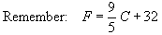
The following are examples of problems converting temperatures given in Celsius to Fahrenheit.
Example 1: Convert 15º C to º F.
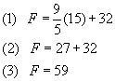
Step 1: Substitute 15 in for C.
Step 2: Multiply 9/5 and 15.
Step 3: Add 27 to 32.
Answer: 59 º F
Example 2: A digital thermometer reads 21.4º C. What is the equivalent Fahrenheit temperature? Round your answer to the nearest degree.
.
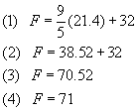.
Step 1: Substitute 21.4 in for C.
Step 2: Multiply 9/5 and 21.4
Step 3: Add 38.52 and 32.
Step 4: Round your answer to the nearest degree.
Answer: 71º F
As an additional activity, place a Celsius thermometer outside where it can easily be seen from the house. Have the student take two readings a day, one in the morning and one at night. Then, have the student convert the temperatures to the Fahrenheit scale. This will allow the student to work with actual measurements and track the weather over a given interval of time. If a thermometer is unavailable, the high and low temperature can be read from the newspaper or the Internet.

Area of Parallelogram - B
A parallelogram is a quadrilateral (a four-sided figure) with two pairs of parallel and congruent sides. Area is the measure, in square units, of the interior region of a two-dimensional figure.

To find the area of a parallelogram, multiply the length of the base (b) by the height (h). The base is one of the sides of the parallelogram. The height is the length of the segment going from the base at a right angle (or perpendicular) to the opposite side. Here is the formula:
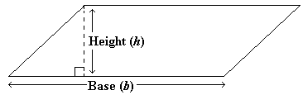
Area of a parallelogram = base height
Example 1: Find the area of the parallelogram.
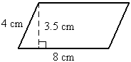
Solution:
The formula for the area of a parallelogram is Area = base height. The height of this parallelogram is 3.5 cm and the base is the length of the side that the height is perpendicular to, in this case, 8 cm. Therefore, the area of the parallelogram is 3.5 cm 8 cm = 28 cm²
Answer: 28 cm² .
One way to help the student reinforce the concept of finding the area of parallelograms is to use a ruler to draw a few parallelograms. Have the student measure the base and height of the parallelograms and then calculate the area using the formula given above. Also, try to find parallelograms in real world figures (such as those in designs) that can be measured so the area can be computed.

Scale Drawing - B
A scale drawing represents an object's actual proportions, but in a smaller size. The scale is a ratio that compares the measurement on a map or drawing to the actual measurement.

It may be helpful to have the student develop his or her own scale drawing for either a room or your home.
Example 1:
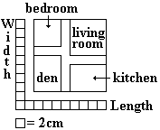
The scale of this drawing is: 2 centimeters equal 5 meters. What is the width of the bedroom?
Solution: One method is to use the ratio of the scale to determine the unknown length. We can use the ratio to write a proportion, using a variable to represent the width of the bedroom. From the scale drawing, we know the scale width of the bedroom is 6 cm. So we write the proportion as follows:
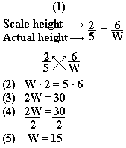
Step 1: Write the appropriate proportion. Let w represent the width of the bedroom.
Step 2: Write the cross products. Multiply w by 2 and multiply 5 by 6.
Step 3: Rewrite the equation with the new values.
Step 4: Divide both sides of the equation by 2 to isolate the w.
Step 5: 30 ÷ 2 = 15
Answer: The width of the bedroom is 15 meters.
Example 2: The blueprints for Mr. Fitzpatrick's new house in New York have a scale of 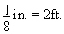What is the area of his library if its dimensions on the blueprint are 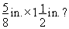
Solution: To find the area, the length and width must be known.
Calculate the length.
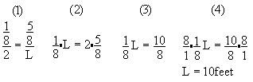
Step 1: Write the appropriate proportion. Let L represent the length of the library.
Step 2: Write the cross products. Multiply L by 1/8 and multiply 2 by 5/8.
Step 3: Rewrite the equation with the new values.
Step 4: Multiply both sides of the equation by 8/1 to isolate the L.
Step 5: Length = 10 feet
To calculate the width:
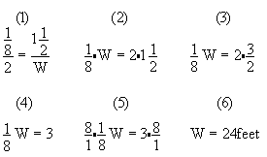
Step 1: Write the appropriate proportion. Let w represent the width of the library.
Step 2: Write the cross products. Multiply w by 1/8 and multiply 2 by 1 1/2.
Step 3: Rewrite the mixed fraction 1 1/2 as an improper fraction, 3/2.
Step 4: Multiply, then rewrite the equation with the new values.
Step 5: Multiply both sides of the equation by 8/1 to isolate the w.
Step 6: Width = 24 feet
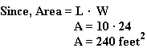
Answer: 240 square feet

Perimeter - C
Perimeter is the measurement of the distance around a figure.

To calculate the perimeter of a figure, add the lengths of all the sides of the figure.
Example 1: What is the perimeter of a figure that has four sides measuring 3 inches, 7 inches, 3 inches and 7 inches?
P = 7 + 3 + 7 + 3 = 20
Answer: 20 inches
Example 2: What is the perimeter of the figure?
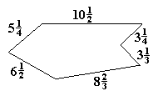
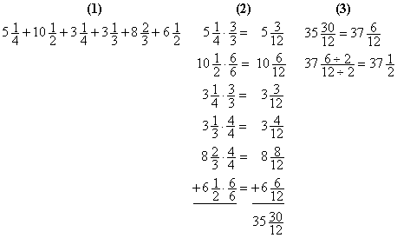Step 1: Add the length of each side together.
Step 2: Since the length of each side includes a fraction, it may be easier to add the numbers vertically. Find the common denominator. The common denominator is 12 because 2 x 3 x 4 = 12. Rewrite the fractions so they all have the common denominator (12).
Step 3: 30/12 is an improper fraction because the numerator (top number) is larger than the denominator (bottom number). Twelve will divide into 30 two times with 6 left over. Add the 2 to the 35 and now the fraction is 37 6/12. Six and 12 can both be divided by six, so the final answer is 37 1/2.
Answer: 37 1/2

Area of Trapezoid
The area of a trapezoid is the number of square units needed to cover the surface of the figure.

The following is the formula needed for calculating the area of a trapezoid:
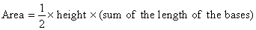
Example 1: Solve for the area of a trapezoid with bases equal to 6 meters and 8 meters, and height equal to 4 meters.
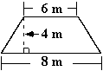
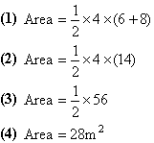
Step 1: Apply the amounts given in the problem to the formula.
Step 2: Add the numbers within the parentheses.
Step 3: Multiply the whole numbers.
Step 4: Perform calculations to find the answer.
Answer: 28 square meters
Example 2: Find x if the area of the trapeziod is 73.5 centimeters squared.
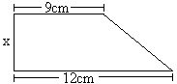
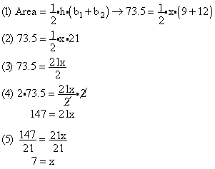
Step 1: Apply the given values to the formula for the area of a trapeziod. (NOTE: This time you are given the area of the trapeziod.)
Step 2: Add the numbers within the parentheses.
Step 3: Perform the multiplications on the right side of the equation.
Step 4: Multiply both sides of the equation by 2. Simplify.
Step 5: Divide both sides of the equation by 21.
Answer: x = 7

Area of Circle
The area of a circle is the number of square units needed to cover the surface of the figure.

The following is the formula needed for calculating the area of a circle:
Pi is approximately equal to 3.14. The symbol for Pi is The radius is the length from the center of the circle to the outside edge. The diameter is the line segment that connects two points on the outside edge of the circle and passes through the center of the circle. The length of the diameter is twice the length of the radius.
Example 1: Solve for the area of a circle with a radius equal to 4 meters.
(1) Area = 3.14 x (4 x 4)
(2) Area = 3.14 x 16
(3) Area = 50.24
Step 1: Apply the amounts given in the problem to the formula.
Step 2: Multiply the numbers within the parentheses.
Step 3: Perform calculations to find the answer.
A semicircle is half of a circle. The area of a semicircle is exactly half of the area of a circle with the same radius.
Example 2: What is the area of the following semicircle? Round your answer to the nearest hundredth.
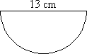
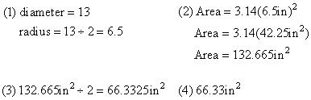
Step 1: The diameter of the semicircle is 13 inches, so the radius is 13 inches divided by 2 (6.5 inches).
Step 2: Determine the area of a circle with radius 6.5 inches.
Step 3: Divide the area of the circle by 2 to find the area of the semicircle with radius 6.5 inches.
Step 4: Round 66.3325 to the nearest hundredth.
The area of the semicircle is 66.33 square inches.

Volume of Rectangular Prisms
Volume is the measurement of a three-dimensional figure's interior space. Volume is measured in cubic units.

The formula for calculating volume of a rectangular prism is:
Volume = length x width x height
Example 1: Find the volume of a rectangular prism with length = 6 inches, width = 4 inches,
height = 2 inches.
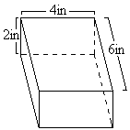
(1) Volume = 2 x 4 x 6
(2) Volume = 48 cubic inches
Step 1: Apply the amounts given in the problem to the formula.
Step 2: Perform calculations to find the answer.
Answer: 48 cubic inches
Example 2: What is the height of the rectangular prism with volume =10 cubic meters, length = 2 meters, and width = 1 meter?
(1) 10 = (2)(1)(h)
(2) 10 = 2(h)
(3) 5 = h
Step 1: Substitute the known values into the formula for the volume of a rectangular prism.
Step 2: Multiply 2 by 1 by h to get 2(h).
Step 3: Divide both sides of the equation by 2 to get that h = 5.
Answer: 5 meters

Volume of Triangular Prism
Volume is the measurement of a three-dimensional figure's interior space. Volume is measured in cubic units. A triangular prism has a triangular base and three lateral faces.

The formula for calculating the volume of a triangular prism is:
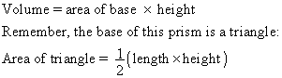
Example 1: Find the volume of a triangular prism with the length of the triangular face equal to 5 meters and the height of the triangular face equal to 2 meters. The height of the prism is equal to 4 meters.
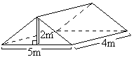
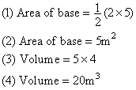
Step 1: Find the area of the base (triangle). Apply the known amounts from the problem to the formula.
Step 2: Perform calculations to find the area of the base.
Step 3: Find the volume of the triangular prism. Apply the known amounts from the problem to the formula.
Step 4: Perform calculations to find the answer.

Volume of Cylinders
Volume is the measurement of a three-dimensional figure's interior space. Volume is measured in cubic units. A cylinder is a solid with two bases that are congruent circles.

The formula for calculating volume of a cylinder:
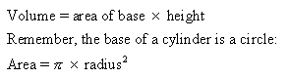
Remember, pi is approximately 3.14. The symbol for pi is Example 1: Solve for the volume of a cylinder with the radius equal to 4 meters and a cylinder height equal to 10 meters.
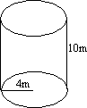
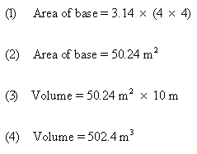
Step 1: Find the area of the base (circle). Apply the known amounts from the problem to the formula.
Step 2: Perform calculations to find the area of the base.
Step 3: Find the volume of the prism. Apply the known amounts from the problem to the formula.
Step 4: Perform calculations to find the answer.
Answer: 502.4 cubic meters

