Study Guide
7th Grade Geometry Practice
05/17/2016

Similar Figures - C
Similar figures are figures that have the same shape, but not necessarily the same size.

Imagine that you have reduced or enlarged a figure in a photocopy machine - the figure has the same shape, but not the same size. In similar figures:
• corresponding angles are congruent (or equal)
• corresponding sides are proportional.
Similar triangles have the same angles, but the length of the sides are shorter or longer. However, the length of the sides must be proportional. This means that if one of the sides is twice as long as the corresponding side of the other triangle, then all the sides must be twice as long as the corresponding sides of the other triangle.
Example 1: If we have a triangle with side lengths of 2, 3, and 4 and a larger similar triangle with the shortest side equal to 6, what is the length of the other two sides of the triangle?
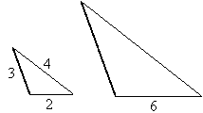
Solution: First, draw the figures so you can visualize the problem. Since the shortest side of the first triangle is 2, we know that 2 x 3 is 6, so the other sides are 3 times the sides of the first triangle. The other two sides are 9 and 12 (3 x 3 = 9 and 4 x 3 = 12).
We can also solve these types of problems using proportions.
Example 2: A rectangle has width equal to 10 feet and length equal to 16 feet. A similar rectangle has length equal to 22 feet. What is its width of the second rectangle?
First, draw the figures so you can visualize the problem.
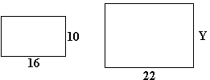
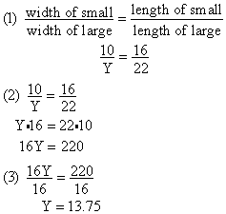
Step 1: Set up the proportion to solve for y.
Step 2: Cross multiply.
Step 3: Divide each side of the equation by 16.
Answer: 13.75 feet

Spatial Relationships - B
Spatial relationships include geometric transformations. A transformation is a mapping of a point or shape to a new location or orientation. Transformations include reflections, rotations, dilations, or translations. All transformations except for dilations preserve the original size and shape of the image.

First, we'll define each of the transformations mentioned above:
A translation is sliding of a figure from one location to another. (Also called a "slide.")
For example:
A dilation is the image of a figure similar to the original figure. It can be thought of as shrinking or enlarging a figure.
For example:
A reflection is flipping a figure across a line, just as you would reflect your hand in a mirror.
For example:
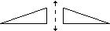
A rotation is the movement of a figure in a circular motion around a point. If you drew a figure on a piece of paper, put the paper on the desk, and turned the paper, you would have a rotation.
For example:
It might be helpful to draw figures on a piece of paper, and rotate them to illustrate rotation of figures.
Example 1: What transformation was performed on the following figure?
The answer is a rotation.
We can use a coordinate plane to show where the parts of a shape are. If we draw the x- and y-axes, we divide the coordinate plane into four parts, each called a quadrant. The quadrants are numbered as follows:
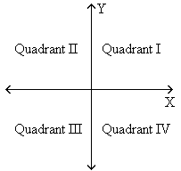
If we reflect a figure (triangle ABC) over the x-axis, what are the coordinates of the reflected figure? (Use "prime" notation A' to identify the image. A' can be read "A prime.")
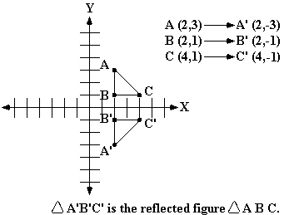
A translation moves a figure to another location. Below is triangle ABC moved 3 units left and 5 units down. We can find the coordinates as follows:
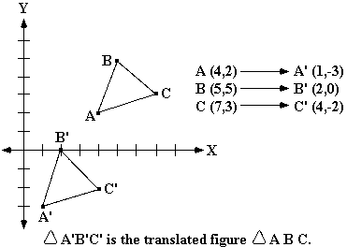

Coordinate Geometry - C
A coordinate graph is used to name the position of points. The x-coordinate (horizontal) is listed first and the y-coordinate (vertical) is listed second. For example, the coordinate pair (3, 2) is at the horizontal position 3 and the vertical position 2.

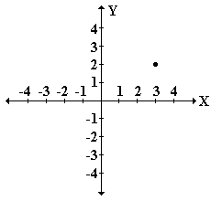
It may be helpful to use graph paper to develop a coordinate graph. Help the student plot points on the graph and determine the coordinate pair.
Example 1: What is the ordered pair for point J?
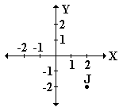
Answer: (2, -2) because the point J is 2 units over and 2 units down.

Angles - B
An angle is created by two rays with the same endpoint. That endpoint is called the vertex.

An interesting method for improving the student's understanding of angles is to have him or her draw the various types of angles. Then, develop a series of flash cards. On one side of the card, draw the figure. On the other side of the card, write the name. The following are definitions to help get you started:
Obtuse Angle - an angle with a measure greater than 90 degrees and less than 180 degrees
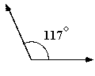
Right Angle - an angle with a measure equal to 90 degrees
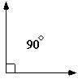
Acute Angle - an angle with a measure greater than 0 degrees and less than 90 degrees
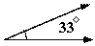
Adjacent angles - two angles with a common vertex and a common side
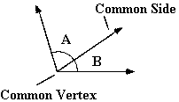
Complementary angles - two angles whose measures have a sum of 90 degrees
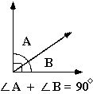
Supplementary angles - two angles whose measures have a sum of 180 degrees
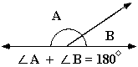
Vertical angles - opposite angles formed by two intersecting lines; vertical angles are congruent
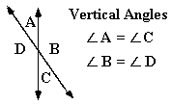

Triangles - A
A triangle is a polygon with three sides.

The following are common triangles used at this level:
Scalene Triangle - a triangle with three unequal sides
Isosceles Triangle - a triangle with at least two equal sides
Equilateral Triangle - a triangle with three equal sides
Right Triangle - a triangle with one right (90º ) angle
It is also important for the student to understand that the sum all of the angles in a triangle equals 180º .
Example 1: If one angle of a triangle is 10º and a second angle is 45º , what is the measure of the third angle?
(1) 10º + 45º = 55º
(2) 180º - 55º = 125º
Step 1: Add the measures of the two known angles.
Step 2: Since the measures of the three angles of a triangle add up to 180º , subtract 55º from 180º .
Answer: The measure of the third angle is 125º .
An alternate method for determining the measure of the third angle of a triangle is to set up an equation.
Example 2: A triangle has two angles, each measuring 47º . What is the measure of the third angle?
(1) 180º = 47º + 47º + x
(2) 180º = 94º + x
(3) 180º - 94º = 94º + x - 94º
(4) 86º = x
Step 1: Since the sum of the angles of a triangle equals 180º , let 180º = 47º + 47º + x where x represents the measure of the third angle.
Step 2: Combine like terms (47º +47º = 94º )
Step 3: To isolate x, subtract 94º from both sides of the equation.
Step 4: Simplify both sides of the equation.
Answer: The measure of the third angle is 86º .

Lines/Segments/Points/Rays
At this level, the lines skill involves the following concepts: lines, rays, points, and segments.

It is important for the student to understand the following definitions:
Point - a specific location on a figure, usually on a line or plane
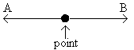
Line - a straight path extending in both directions with no endpoints. A line AB is denoted as
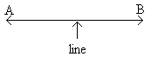
Segment - a part of a line that ranges from one point to another. A line segment AB is denoted as
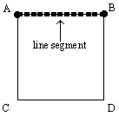
Ray - a part of a line that continues forever in one direction from its endpoint. A ray BA with endpoint B is denoted as
Skew lines - lines that are not intersecting and are not parallel.
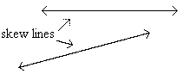
Parallel lines - lines in the same plane that do not intersect. Parallel lines have no points in common.
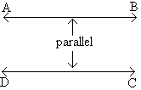
Perpendicular lines - two lines that intersect and form right angles. Perpendicular lines have only one point in common.
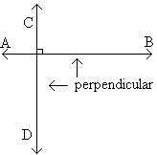
Point of intersection - the point at which lines cross.
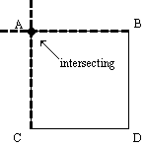
Transversal - a line that intersects 2 or more lines.
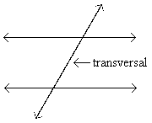
One method for improving the student's understanding of these concepts is to have him or her develop a series of flash cards with the definition on one side and the written name on the back.

Polygons - B
A polygon is a closed shape formed by three or more sides. For example, a triangle is a polygon with three sides and a quadrilateral is a polygon with four sides.

It may be helpful to verify that the student is familiar with different polygons commonly taught in this grade. The following is a list of polygons and their definitions.
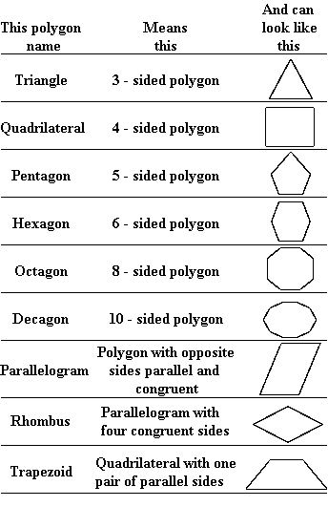
A line segment is a part of a line that is bounded by two endpoints.
A diagonal is a line segment that joins two vertices of a polygon, but is not a side of the polygon.

Congruency - C
Congruent figures have the same shape and size.

It may be beneficial to verify that the student understands the definition of similar and congruent figures.
To help understand congruence, draw two triangles exactly the same shape and size (use graph paper or a copy machine to ensure the figures are the same). Draw an additional triangle of a different shape and size. Cut out each figure. Arrange the figures on a table and ask the student to find the congruent triangles. Remember, two figures are congruent if they are the same shape and size.
Symmetry:
A figure is said to have a line of symmetry when it can be folded in half along that line so that the two halves are congruent. One artistic way to help the student understand symmetry is for you to draw half of a simple shape (such as a square, circle, triangle, or heart) on a piece of paper and have the student draw the other half. Fold the paper on the halfway line and compare to see if both sides match.
A vertical line of symmetry crosses through the figure vertically. A horizontal line of symmetry crosses through the figure horizontally. A diagonal line of symmetry crosses through the figure at a diagonal.
The following three figures show the lines of symmetry (dotted lines):
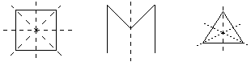

Symmetry - B
To determine lines of symmetry, imagine a line cutting a figure into two parts. If the pieces were placed on top of each other, the two parts would be exactly the same. The line where the figure was cut is called the
line of symmetry. Figures that can be divided into two parts that are exactly the same are called symmetric across a line.
Imagine folding a figure cut out of a piece of paper in half so the figure fits perfectly over the other half of the figure, this is called a figure that is symmetric.

Below are examples of figures that when divided into two parts across the line of symmetry would fit together exactly. Notice that some figures have more than one line of symmetry.
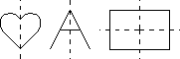
It may be helpful to cut figures out of construction paper and try to decide how many lines of symmetry there are in the figure. Then, fold or cut the figure across the determined lines of symmetry to check for symmetry.
Example 1: How many lines of symmetry are in the following figure?
The answer is 2. The figure has a vertical and horizontal line of symmetry.
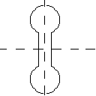

Graphing Equations - A
Students must graph an equation (such as y = 3x - 5) on the coordinate plane.

Example 1: Graph: y = x + 3
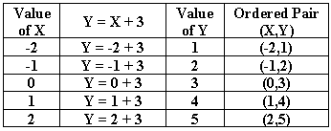
Step 1: When given an equation, such as y = x + 3, the first step is to make a table of ordered pairs. Select a list of values for x and then calculate the values of y.
Step 2: Graph the ordered pairs you calculated in Step 1. Remember, the x-value moves left (negative) or right (positive) from zero and the y-value moves up (positive) or down (negative) from the x-value.
If you connect the points, this equation will create a straight line.
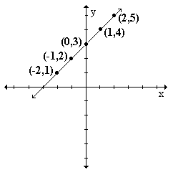
In order to determine whether a set of ordered pairs is a solution to the graph of a line, you substitute those values in for the variables.
Example 2: Which of the following points is a solution to the graph of the line, y = 2x + 4?
A. (2,7)
B. (1,6)
C. (1,3)
Substitute the x- and y-values from the ordered pairs into the equation y = 2x + 4.
(2, 7): 7 = 2(2) + 4 (1, 6): 6 = 2(1) + 4 (1, 3): 3 = 2(1) + 4
7 = 8 6 = 6 3 = 6
false true false
The answer is: (1, 6) is a solution to the graph because its values of x and y make the equation true.
An equation that represents a line has an infinite number of solutions because there are two variables in the equation. If one of the variables is fixed, then there will only be one solution to the equation.
Example 3: If the equation y = 3x + 1creates a straight line, how many solutions to the equation are there?
Solution: There are an infinite number of solutions because for every value of x, a different value of y can be found.
Example 4: If 2y = x - 4 and x = 1, how many solutions to the equation are possible?
Solution: There is only one possible solution because if x = 1, 2y = 1 - 4, so y = -3/2. For each value of x, there is only one value for y.

