Study Guide
7th Grade Data Analysis and Probability Review
05/18/2016

Measures of Central Tendency: Apply
The study of statistics involves looking at the measures of central tendency. Measures of central tendency are numerical values used to describe the overall clustering of data in a set. They include mean, median, and mode. Although range is a measure of spread, it is often included when learning measures of central tendency. This study guide will focus on the application of these measures within real world problems.

It is important to review the definitions and calculation procedures for determining mean, median, mode, and range with the student. This will help to prepare the student before progressing to real world problems.
The mean of a group of numbers is found by adding the numbers and then dividing the sum by the number of addends (items in the group). It is also referred to as the average.
The median is the middle number, or the mean of the two middle numbers, of a group of numbers ordered sequentially.
The mode of a group of numbers is the number that occurs most often. Sometimes the mode is referred to as the most typical number. If every number only occurs once, there is no mode. If more than one number occurs with the same frequency (other than once), there can be multiple modes.
The range of a group of numbers is the difference between the highest number and the lowest number. The range is the number that tells how widespread the data is.
Example 1: Find the mean of 15, 10, 5, 20, 5.
Solution:
(1) 15 + 10 + 5 + 20 + 5 = 55
(2) 55 ? 5 = 11
Step 1: Find the sum of the numbers.
Step 2: Divide by 5, the total number of addends (items in the group).
Answer: The mean is 11.
Example 2: Find the median of 9, 1, 3, 5, 0, 7.
Solution:
(1) 0, 1, 3, 5, 7, 9
(2) 3 and 5
(3) 3 + 5 = 8
8 ? 2 = 4
Step 1: Put the numbers in order from least to greatest.
Step 2: Determine the middle number(s). Since there is an even amount of numbers, there are two middle numbers. If there is an odd amount, there will be just one, and that will be the median.
Steps 3: Determine the mean of 3 and 5 by adding the two numbers together and dividing by 2.
Answer: The median is 4.
Example 3: Find the mode of 0, 6, 7, 9, 6, 4, 3.
Solution:
(1) 0, 3, 4, 6, 6, 7, 9
(2) 0, 3, 4, 6, 6, 7, 9
Step 1: It may be easiest to list the numbers in order, allowing the student to clearly see numbers that repeat.
Step 2: Determine the number that occurs most often.
Answer: The mode is 6 because it occurs twice and the other numbers only occur once.
REMEMBER: There can be zero, one, or multiple modes.
Example 4: Find the range of 9, 5, 16, 8, 2, 3.
Solution:
(1) 16 - 2 = 14
Step 1: Subtract the lowest value in the set from the highest value.
Answer: The range is 14.
Using Measures of Central Tendency Within Real World Problems:
A common mistake students make is calculating the wrong measure of central tendency because they have forgotten which one is which. A couple of easy tricks to help the student remember these definitions are:
•The word mode has the same amount of letters and starts the same way as the word most. Therefore, mode should remind the student to find the number that occurs the most.
•The word median contains the prefix 'med', just like the word medium, which is in the middle of small and large. Also, it may help if the student remembers that a median on a street is the area in the middle of the lanes. Therefore, median should remind the student to find the number that is located in the middle.
In this skill, students will be required to find and use the most appropriate measure of central tendency in a real world scenario.
Example 5:
The average high temperatures in London, England are given for each month of the year: 44º F, 45º F, 50º F, 55º F, 61º F, 67º F, 71º F, 72º F, 66º F, 59º F, 50º F, and 46º F. Which measure is most appropriate to use to make the temperature appear the lowest?
(1) range: 72 - 44 = 28
(2) mean: 44 + 45 + 50 + 55 + 61 + 67 + 71 + 72 + 66 + 59 + 50 + 46 = 686. 686 ÷ 12 = 57.167.
(3) median: 44, 45, 46, 50, 50, 55, 59, 61, 66, 67, 71, 72. 55 + 59 = 114. 114 ÷ 2 = 57.
(4) The mode is 50.
(5) 57.167 > 57 > 50 > 28
Step 1: Determine the value of the range. Subtract the smallest number from the largest number: 28º .
Step 2: Determine the value of the mean. Add all the numbers in the data set together, to get 686. Then divide this by the number of addends in the data set, in this example, 12. The mean, when rounded to the nearest thousandth is 57.167º .
Step 3: Determine the median. Write all of the numbers in order and determine the middle value. Because there is an even number of values, it is the mean of the middle two numbers, 55 and 59. The median is equal to 57º .
Step 4: Determine the mode. The number that occurs most often in the set is 50 because it is the only number in the set given more than once. Therefore, the mode is equal to 50º .
Step 5: Compare the four values to determine which has the lowest value and is the most appropriate. In this case, the lowest value was 28 which was the range, but the range is not the most appropriate measure to use because it is a measure of the spread of the temperatures rather than a measure of the data between the highest and lowest numbers. Also, the range is much lower than any of the temperatures in the data set. The next lowest number is 50, the mode.
Answer: The mode is the most appropriate measure to use to make the temperature appear the lowest.
Example 6:
The number of grams of carbohydrates from a variety of candy bars are given: 28, 25, 27, 25, 36, 38, 59 and 32. Which measure best represents the number of grams of carbohydrates in the candy bars?
(1) range: 46 - 25 = 21
(2) mean = 28 + 25 + 27 + 25 + 36 + 38 + 59 + 32 = 270. 270 ÷ 8 = 33.75
(3) median = 25, 25, 27, 28, 32, 36, 38, 59. 28 + 32 = 60. 60 ÷ 2 = 30.
(4) mode = 25
Step 1: Determine the range (21).
Step 2: Determine the mean (33.75).
Step 3: Determine the median (30).
Step 4: Determine the mode (25).
Solution: Now, the numbers must be interpreted to determine the one that best represents the data.
The range is smaller than the other numbers in the data set, so it does not the best represent the data.
The mode is the smallest number in the data set, so it does not the best represent the data.
The mean is made higher by the 59 (which is an outlier: a number that is much larger or much smaller than the other numbers in the data set), so it does not the best represent the data.
The median has exactly four numbers on each side of it and is not affected by the 59, so it best represents the data.
Answer: The number of grams of carbohydrates is best represented by the median.
Example 7:
The number of gold medals that the United States has won in the last several Olympics games are 34, 36, 45, 33, 34, 83, 36, 37, 44, and 40. Which measure will show how widespread this data is?
Answer: The range provides information about the spread of data.
As an additional activity, have the students calculate the mean, median, mode, and range of a variety of grocery or department store receipts. If the receipts are long and contain too much data, restrict the calculations to just certain items. Finally, have the students determine which measure of central tendency to use if they want to make the prices appear the highest or the lowest, if they want to explain how widespread the prices are, and if they want the most typical value on the receipt.

Circle Graphs - B
A graph is a visual aid used to show and compare information. A circle graph, or pie chart, is often used to show data given in percentages. An interesting method for increasing the student's understanding of graphs is to help him or her develop a graph for a school project or event.

Have the student create a circle graph for the events that typically occur during a normal day. Remind the student that the total for a circle graph or pie chart is always 100% or one whole. So, if he or she spends half of his or her day at school, then half (50%) of the circle would be filled with the title "School." Similarly, if one-quarter (25%) of his or her day is spent at the soccer field, then a quarter of the pie would be titled "Soccer." The following is an example:
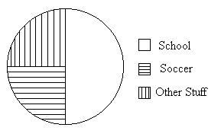
Example 1: This circle graph represents how Chelsea spends her time each day. Use the circle graph to answer the question.
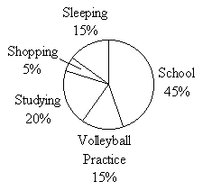How much of her time does Chelsea spend practicing volleyball and shopping?
(1) Volleyball Practice = 15%, Shopping = 5%
(2) 15% + 5% = 20%
Step 1: According to the circle graph, Chelsea spends 15% of her time at volleyball practice and 5% of her time shopping.
Step 2: To find the total amount of time, add the percentages together.
Answer: Chelsea spends 20% of her day practicing volleyball and shopping.
Example 2: The circle graph below shows the distribution of types of donuts prepared each morning by a local donut shop. Use the circle graph to answer the question.
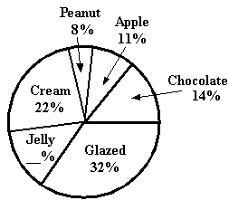
What percentage of the prepared donuts contain jelly?
(1) Glazed = 32%, Chocolate = 14%, Apple = 11%, Peanut = 8%, Cream = 22%
(2) 32% + 14% + 11% + 8% + 22% = 87%
(3) 100% - 87% = 13%
Step 1: List all of the existing percentages shown in the circle graph.
Step 2: Since the percentages in a circle graph must always add up to 100%, begin by adding the existing percentages.
Step 3: Next, subtract the total from step 2 (87%) from 100%.
Answer: 13% of the prepared donuts contain jelly.
Example 3: The circle graph below shows the distribution of the types of dinner rolls served each night at the Bread Basket Restaurant. Use the circle graph to answer the question.
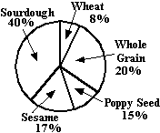
If the desire for poppy seed rolls increases by 5%, which of the following graphs could accurately show this change?
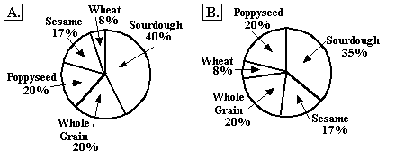
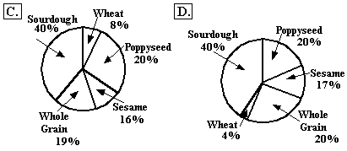
Choice (A) is not the answer because although poppy seed increased to 20%, none of the other types decreased. Therefore, the total of the graph is now over 100%.
Choice (B) is the answer because the new percentages reflect the increase in the desire for poppy seed rolls, while there is also a decrease in the desire for sourdough. Therefore the percentages add up to 100%.
Choice (C) is not the answer. Although poppy seed increased to 20%, the others did not adjust accordingly. Therefore, the total of the graph is now over 100%.
Choice (D) is not the answer. Although poppy seed increased to 20%, the others did not adjust accordingly. Therefore, the total of the graph is now over 100%.
Answer: Choice B.

Bar Graphs - D
A bar graph is a visual aid used to show and compare data. A bar graph has rectangular bars of various lengths which represent specific information.

An interesting method for increasing the student's understanding of graphs is to help him or her develop a graph for a school project or event, such as a magazine sale. The following is an example of a bar graph.
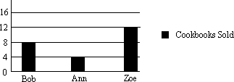
A double bar graph is used to display two sets of data. The following is an example of a double bar graph. It compares the amount of miles that Sarah ran each day to the amount of miles that Sally ran each day.
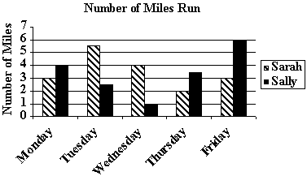
Example 1: On which days did Sarah run more miles than Sally?
Answer: Sarah ran more miles than Sally on Tuesday and Wednesday. On these days, the bar representing Sarah's mileage is higher than the bar representing Sally's mileage.
Example 2: How many total miles did Sally run?
(1) On Monday, the bar representing Sally's mileage goes to 4 miles.
(2) On Tuesday, the bar goes to 2.5 miles.
(3) On Wednesday, the bar goes to 1 mile.
(4) On Thursday, the bar goes to 3.5 miles.
(5) On Friday the bar goes to 6 miles.
(6) Add these five numbers together: 4 + 2.5 + 1 + 3.5 + 6 = 17.
Answer: Sally ran a total of 17 miles.

Tables - E
Tables are created to communicate information visually. Students are expected to interpret data from tables.

A creative method for improving the student's data interpretation skills is to use actual tables from magazines or books. Help the student understand the information provided in these tables.
The following is a sample multiplication table. The top row contains even numbers. The left column contains odd numbers.
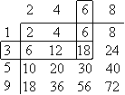
Example 1: What is 6 times 3?
Select a number from the top row (6) and a number from the left column (3). Follow the top number down and the left column number across until the two meet (18).
Answer: 18.
The following table shows the average amount of students attending Mr. Ranney's math class. The top row lists the different months, September through January. The left column lists the period numbers 1 through 6.
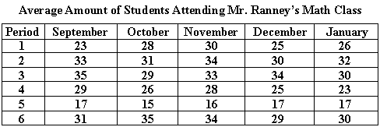
Example 2: Use the table above to answer the question. Which class period had the highest average in October?
Look at the column beneath October. The highest number, 35, is from period 6.
Answer: Period 6.
Example 3: Use the table above to answer the question. Which is lower, the attendance in period 2 in January or the attendance in period 4 in November?
(1) Select period 2 from the left column and January from the top row. Follow the left column across and the top row down until they meet at 32.The attendance in period 2 in January was 32.
(2) Select period 4 from the left column and November from the top row. Follow the left column across and the top row down until they meet at 28.
The attendance in period 2 in January was 32.
The attendance in period 4 in November was 28.
Answer: Since 28 is less than 32, the lower attendance was in period 4 in November.

Probability/Statistics - C
Probability is the ratio of the number of times a certain outcome can occur to the number of total possible outcomes. For instance, if the probability that an event will happen is 7 out of 10, this probability could be expressed as 7/10, 7:10 or 70%. Statistics is the study of numerical data. This data is collected, classified, and analyzed to provide a meaningful presentation.

One of the best ways to introduce the student to probability and statistics is to apply them to activities he or she enjoys. If the student likes to play marbles, have him or her put marbles of different colors in a bag. Then, help him or her use probability calculations to figure out the likelihood of certain events. (Example: pulling a blue marble.)
Example 1: If there are 6 green marbles, 3 orange marbles, 2 blue marbles, and 1 black marble in a bag, what is the probability that either an orange or black marble will be blindly pulled from the bag first?
Solution: Start with the number of marbles in the bag. There are 12. Then, figure out how many marbles are either orange or black. There are 4 (3 orange and 1 black). The probability ratio is 4/12, or, in reduced form, 1/3.
The probability that either an orange or a black marble will be blindly pulled out of the bag first is 1/3.
Example 2: Michelle conducted a poll to find out how many of her classmates lived in apartments and how many lived in houses. In the poll, Michelle found that 12 out of 25 classmates lived in apartments. There are 250 people in her class. How many classmates can Michelle expect to live in apartments?
Solution: We'll let 'x' represent the number of classmates expected to live in apartments.
Since 12 of 25 live in apartments, 12 is to 25 as 'x' is to 250. We can represent this as a proportion:
12/25 = x/250
We can use algebra to solve by cross multiplication:
(12)(250) = 25x
3,000 = 25x (Divide each side by 25)
x = 120
Michelle can expect that 120 of her classmates live in apartments.

Mean/Median/Mode/Range - A
The study of statistics involves looking at the measures of central tendency. They are the mean, median, and mode.
The mean of a group of numbers is found by adding the numbers and then dividing the sum by the number of addends (items in the group). It is also referred to as the average.
The median is the middle number, or the average of the two middle numbers, of a group of numbers ordered sequentially.
The mode of a group of numbers is the number that occurs the most often.
The range of a group of numbers is the difference between the highest number and the lowest number.

Example 1: Find the mean of 15, 10, 5, 20, 5.
(1) 15 + 10 + 5 + 20 + 5 = 55
(2) 55 ÷ 5 = 11
Step 1: Find the sum of the numbers.
Step 2: Divide by the total number of addends (items in the group).
The mean is 11.
Example 2: Solve for the median of 9, 1, 3, 5, 0, 7.
(1) 0, 1, 3, 5, 7, 9
(2) 3 and 5
(3) 3 + 5 = 8
(4) 8 ÷ 2 = 4
Step 1: Put the numbers in order from smallest to largest.
Step 2: Determine the middle number(s). Since there is an even amount of numbers, there are two middle numbers. If there is an odd amount, there will be just one.
Steps 3 and 4: Determine the mean of 3 and 5 by adding the two numbers together and dividing by 2.
The median is 4.
Example 3: Solve for the mode of 0, 6, 7, 9, 6, 4, 3.
The mode is the number which occurs most often in a group. For this group of numbers the mode is 6 because it occurs twice and the other numbers only occur once. NOTE: There can be more than one mode or there can be no mode at all.
Example 4: Find the range of 9, 5, 16, 8, 2, 3.
(1) 16 - 2 = 14
The range is the difference between the highest number in a group and the lowest number in a group.
16 - 2 = 14
The range is 14.

