Study Guide
6th Grade Measurement Practice
05/24/2016

Units of Measurement - C
The metric system is a system of weights and measures in which the meter, the gram, and the liter are the basic units. Students should be able to convert between different metric measurements.

Units in the metric system can be converted using prefixes. The metric prefixes and their abbreviations are shown below.
milli = m
centi = c
deci = d
kilo = k
hecto = h
deka = da
These prefixes are added to base metric units, like the meter (m), liter (L), and gram (g), to denote different values. For instance, if the prefix kilo (k) is added to the base unit gram (g), it becomes kilogram (kg). A kilogram is 1,000 times larger than a gram, or in other words there are 1,000 grams in a kilogram. The following table shows the relationship between the metric units of length, volume, and weight.
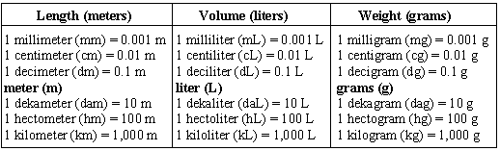
To use this information in a conversion (for example, to convert 0.25 grams to milligrams), first determine how many grams are in 1 milligram. According to the chart, there are 0.001 grams in a milligram. Since the number of base units is known (0.25 grams) and the prefix unit (milligrams) needs to be found, divide 0.25 by 0.001, resulting in 250. There are 250 milligrams in 0.25 grams.
If the number of prefix units is known and the base unit needs to be found, multiply instead of divide. For example, to convert 650 milligrams to grams, we must multiply 650 by 0.001, resulting in 0.65. There are 0.65 grams in 650 milligrams.
Example 1: Solve.
9 dam = ? m
Solution: According to the information in the chart above, 1 dekameter (dam) equals 10 meters (m). Since there are 9 dam, multiply 9 by 10 to get 90 m.
Answer: 90 m
Example 2: How many milliliters are there in 35 liters?
Solution: According to the information in the chart above, 1 milliliter (mL) equals 0.001 liters (L). Since the number of liters is known, divide 35 by 0.001 to determine the number of milliliters (35,000).
Answer: 35,000 mL
To help students understand conversions of metric units, have them measure various items with a metric ruler or meter stick. Once they find the length of each object, have them convert the measurement to another unit.

Temperature - C
Celsius is a standard unit in the metric system for measuring temperature.

Thermometers are used to measure temperatures. Many times on tests and in textbooks, thermometers are represented by drawings. There are three thermometers below, each with a different scale.
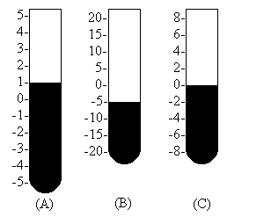
Example 1: Refer to thermometer A above. If the temperature dropped 2.5º C, what would the temperature read?
(1) 1º C - 2.5º C
(2) -1.5º C
Step 1: Thermometer A reads 1º C. Since we want to know what will happen if the temperature drops 2.5º C, we subtract 2.5º C from the current reading (1º C).
Step 2: 1º C - 2.5º C = -1.5º C
Answer: -1.5º C

Time - D
Students are expected to be able to answer questions involving telling time, adding hours and minutes, and word problems related to time.

To begin with, students should be able to tell time on a non-digital clock. To review with the student, use an analog (not digital) clock and set the hands at different positions. Have the student tell the time.
The student should also be able to add or subtract time from the clock. For example, if the clock is set at 5:15, what time will it be in two hours? (Answer = 7:15)
It is important that the student know the following time conversions:
60 minutes = 1 hour
24 hours = 1 day
7 days = 1 week
52 weeks = 1 year
365 days = 1 year
The student should be familiar with the distance formula:
distance = rate x time
Example 1: Jen is going to fly her plane to Okinawa, which is 2,000 miles away. Jen's airplane flies at an average speed of 500 miles per hour. How long will it take Jen to fly to Okinawa?
(1) Distance = 2,000 miles; Rate = 500 mph; Time = ?
(2) 2,000 = 500 x Time
(3) 2,000 ÷ 500 = Time
(4) 2,000 ÷ 500 = 4
Step 1: Determine the Distance, Rate, and Time amounts from the problem.
Step 2: Apply the amounts to the formula.
Step 3: Rewrite the problem so that the unknown is on one side of the equation.
Step 4: Perform the calculations.
Answer: It will take Jen 4 hours to fly to Okinawa.

Circumference - A
Circumference is the distance around a circle.

The following is the formula necessary for calculating the circumference of a circle:
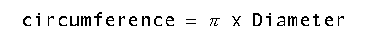
Pi is equal to about 3.14. The symbol for pi is
The diameter is a line segment from one point on the circle through the center of the circle to another point on the circle. The radius is a line segment from the center of a circle to a point on the circle. The length of the diameter of a circle is twice the length of the radius of the circle. For example, if a circle has a radius equal to 6 inches, the diameter equals 2 x 6 inches which is 12 inches.
Example 1: What is the circumference of a circle with a diameter of 12 meters?
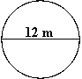
(1) Circumference = 3.14 x 12
(2) Circumference = 37.68m
Step 1: Substitute the value of the diameter into the formula for the circumference of a circle. Remember, pi is equal to about 3.14.
Step 2: Multiply 3.14 by 12 to get the circumference of the circle.
The circumference of the circle is 37.68 meters.

Area of Rectangle - C
The area of a rectangle is the number of square units needed to cover the surface of the figure.

The formula for calculating area of a square or rectangle is:
Area = length x width.
Example 1: A figure has a width of 3 inches and a length of 7 inches. What is the area of the figure?
Step 1: Multiply the width and the length.
Area = 7 x 3 = 21
Answer: 21 square inches
It may be useful to use graph paper to develop figures. Help the student determine the area of various figures drawn on the graph paper.

Area of Parallelogram - A
The area of a parallelogram is the number of square units needed to cover the surface of the figure.

To find the area of a parallelogram, multiply the base(b) by the height(h). The base is the length of the top or the bottom of the figure. The height is the length of a line going from the base at a right angle to the opposite side. Here is the formula:
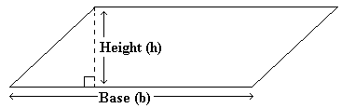
Area of a parallelogram = (base) x (height)
Example 1: Find the area of a parallelogram with a base equal to 5 feet and a height equal to 2 feet?
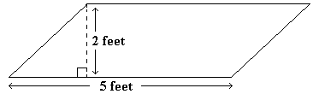
Area = 5 feet x 2 feet = 10 square feet
Answer: 10 square feet
Example 2: What is the value of N?
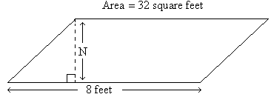
(1) 32 = 8 x N
(2) 4 = N
Step 1: Substitute the known values into the formula for the area of a parallelogram.
Step 2: Divide each side of the equation by 8. (32 ÷ 8 = 4 and 8 ÷ 8 = 1
Answer: 4 feet

Area of Triangle - A
The area of a triangle is the number of square units needed to cover the surface of the figure.

The following is the formula needed for calculating the area of a triangle:
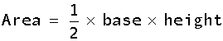
Example 1: Solve for the area of a triangle with base equal to 6 meters and height equal to 4 meters.
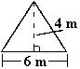
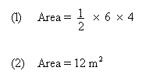
Step 1: Apply the amounts given in the problem to the formula.
Step 2: Perform the calculations to find the answer.
Answer: 12 square meters
Example 2: What is the height of a triangle that has a base of 12 inches and an area of 204 square inches?
(1) 1/2 x 12 x h = 204
(2) 6 x h = 204
(3) h = 34
Step 1: Substitute the known amounts into the formula for the area of a triangle.
Step 2: Multiply 1/2 x 12 = 6 and replace 1/2 x 12 with 6 in the formula.
Step 3: Divide both sides of the equation by 6. (6 ÷ 6 = 1 and 204 ÷ 6 = 34)
Answer: 34 inches

Surface Area
The surface area of a solid figure is the sum of the areas of all the surfaces.

A face is one side of a solid figure. When trying to find the surface area of a figure, first find the area of each face, then add those areas together.
Example 1: Find the surface area of the figure.
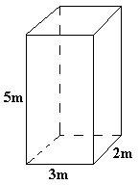
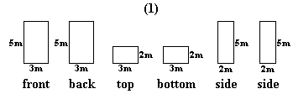
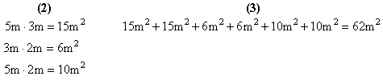
Step 1: This three-dimensional figure can be broken down into its six faces (which are rectangles). The front and back are identical, the top and bottom are identical, and the left and right sides are identical.
Step 2: Determine the area of each rectangle using the formula Area = length x width.
Step 3: Add together the area of each face of the figure.
The surface area of the figure is 62 square meters.
Example 2: Find the surface area of the figure.
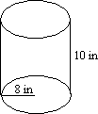
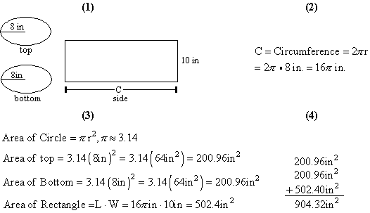
Step 1: Every cylinder has 3 faces: two circles and one rectangle. One way to illustrate this is to roll a rectangular piece of paper into a tube. Each end of the tube is a circle and the tube itself is a rectangle. The top and bottom of the cylinder look like ovals when they are drawn, but they are actually circles. Draw the three faces of the cylinder and label the known parts.
Step 2: The length of the rectangle is not known. It can be found by determining the circumference of the circles. (Circumference is the distance around the circle.) The length of the rectangle is Step 3: Determine the area of each face of the cylinder.
Step 4: Find the sum of the three faces of the cylinder.
The surface area of the cylinder is 904.32 square inches.
Example 3: Find the surface area of the figure.
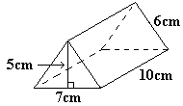
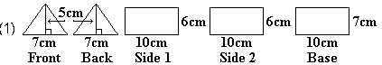
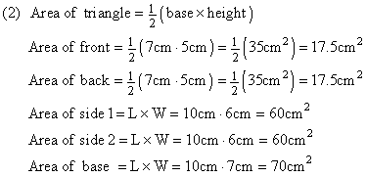
Step 1: This figure has five faces: two triangles and three rectangles. Draw the five faces and label the known parts.
Step 2: Determine the area of each face.
Step 3: Find the sum of the areas of all faces of the figure to determine the surface area of the figure.
The surface area of the figure is 225 square centimeters.

Volume - D
Volume is the measurement of a three-dimensional figure's interior space. Volume is measured in cubic units.

The formula for calculating the volume of a rectangular solid is length multiplied by width multiplied by height.
Volume = length x width x height
Example: A figure has length = 2 inches, width = 4 inches, and height = 6 inches. Multiply the length, width, and height.
V = 2 x 4 x 6 = 48
Answer: 48 cubic inches.
It may be helpful to develop a series of problems and help the student determine the correct volume measurement.

