Study Guide
6th Grade Fractions Practice
05/24/2016

Divide Fractions: Story Problems - B
Story problems, also called word problems, relate division of fractions and mixed numbers to real world situations. Story problems require students to read passages and determine the question being asked. Students should then identify the elements needed to solve the problem, decide on the correct method to solve each problem, and find a solution.

Story problems are often difficult for students to master. It may be beneficial to confirm that the student is comfortable with division of fractions and mixed numbers outside of a real world context. To review this concept with the student, use the examples below.
Dividing Fractions:
Example 1: Divide and reduce your answer to lowest terms.
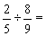
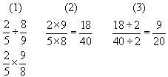
Step 1: Rewrite the problem as a multiplication problem. Dividing by a fraction is the same as multiplying by its reciprocal. To find the reciprocal, simply switch the numerator and the denominator. In this case, the second fraction, 8/9, becomes 9/8 and the ÷ symbol becomes a symbol.
Step 2: Multiply the numerators (2 9 = 18) and the denominators (5 8 = 40).
Step 3: Reduce the fraction to lowest terms. A fraction is in lowest terms when the numerator and denominator do not have a common factor greater than 1. The numbers 18 and 40 can both be divided by 2, so complete this division to reduce the fraction. *An alternate way to reduce the fraction is to reduce before multiplication is completed. This can be done by finding a numerator and a denominator that are both evenly divisible by the same number, such as the numerator 2 and the denominator 8. Both the 2 and the 8 can be divided by 2. Complete the divisions: 2 ÷ 2 = 1 and 8 ÷ 2 = 4, so the new problem would be (1 9)/(5 4) and the answer would be 9/20.
Dividing Mixed Numbers:
Example 2: Divide and reduce your answer to lowest terms.
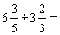
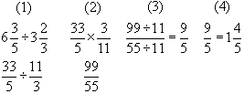
Step 1: Rewrite the mixed numbers as improper fractions. For example, to change 6 3/5 into an improper fraction, multiply the denominator by the whole number (5 6 = 30). Then add that product and the numerator (30 + 3 = 33). The denominator remains the same and 6 3/5 can be written as 33/5. Similarly, 3 2/3 becomes 11/3.
Step 2: Rewrite the problem as a multiplication problem. In this case, the second fraction, 11/3, becomes 3/11 and the ÷ symbol becomes a symbol. Then, multiply the numerators and denominators.
Step 3: Reduce the fraction to lowest terms. The numbers 99 and 55 can both be divided by 11, so complete this division to reduce the fraction.
Step 4: Rewrite the fraction as a mixed number. Divide the numerator by the denominator. Write the quotient as the whole number and leave the remainder in the numerator position. For example, 9 divided by 5 is 1 with a remainder of 4. The denominator remains 5.
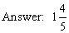
Remember, when the division involves whole numbers, use 1 as the denominator for the whole number.
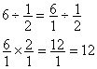
When given a problem that involves dividing a fraction by a mixed number or a mixed number by a fraction, the process is very similar to the above process of dividing two mixed numbers. The only difference is that in Step 1, only one mixed number needs to be converted into an improper fraction because the other number is already in the correct form.
Dividing Fractions and Mixed Numbers in a Real World Context:
Example 3:
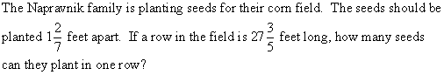
Solution:
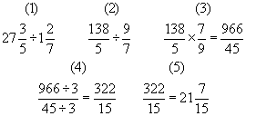
Step 1: Determine the problem that you are trying to solve. For this problem we want to break 27 3/5 feet into pieces that are 1 2/7 feet long. Therefore we need to divide 27 3/5 by 1 2/7.
Step 2: Rewrite the mixed numbers as improper fractions. To change 27 3/5 into an improper fraction, multiply the denominator by the whole number (5 27 = 135). Then add that product to the numerator (135 + 3 = 138). The denominator remains the same and 27 3/5 can be written as 138/5. Similarly, 1 2/7 becomes 9/7.
Step 3: Rewrite the problem as a multiplication problem. In this case, the second fraction, 9/7, becomes 7/9 and the ÷ symbol becomes a symbol. Then, multiply the numerators and denominators.
Step 4: Reduce the fraction to lowest terms. The numbers 966 and 45 can both be divided by 3, so complete this division to reduce the fraction.
Step 5: Rewrite the fraction as a mixed number. Divide the numerator by the denominator. Write the quotient as the whole number and leave the remainder in the numerator position. In this example, 322 divided by 15 is 21 with a remainder of 7.
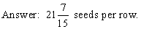
Example 4:
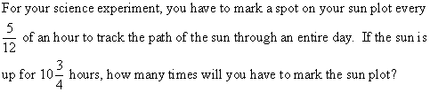
Solution:
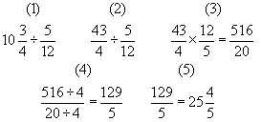
Step 1: Determine the problem that you are trying to solve. For this problem we want to break 10 3/4 hours into 5/12 of an hour pieces. Therefore we need to divide 10 3/4 by 5/12.
Step 2: Rewrite the mixed numbers as improper fractions. To change 10 3/4 into an improper fraction, multiply the denominator by the whole number (4 10 = 40). Then, add that product to the numerator (40 + 3 = 43). The denominator remains the same and 10 3/4 can be written as 43/4.
Step 3: Rewrite the problem as a multiplication problem. In this case, the second fraction, 5/12, becomes 12/5 and the ÷ symbol becomes a symbol. Then, multiply the numerators and denominators.
Step 4: Reduce the fraction to lowest terms. The numbers 516 and 20 can both be divided by 4, so complete this division to reduce the fraction.
Step 5: Rewrite the fraction as a mixed number. Divide the numerator by the denominator. Write the quotient as the whole number and leave the remainder in the numerator position. In this example, 129 divided by 5 is 25 with a remainder of 4.
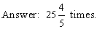
An that activity will give the student practice with this skill is to have the student start with a standard 8 1/2 11 inch piece of paper. For the short dimension, compute how many 1/4-inch pieces will fit across and then measure with a ruler to check if he or she is correct. Repeat the process using different increments such as 1 2/3 inches, 4/5 of an inch, and 3 5/6 inches. Compute the result first and measure with a ruler to check.

Multiply Whole and Mixed Numbers
A mixed number is a number written as a whole number followed by a fraction. Students must be comfortable rewriting mixed numbers as improper fractions and vice versa. Improper fractions are fractions in which the numerator is larger than the denominator. This form allows students to easily multiply two fractions, two mixed numbers, two whole numbers, or any combination of the three.

Remember:
In order to write a mixed number as an improper fraction, multiply the denominator by the whole number and then add the numerator. The result then becomes the numerator and the original denominator remains the same.
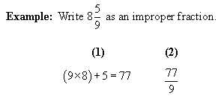
Step 1: Multiply the denominator (9) by the whole number (8) and then add the numerator (5).
Step 2: Rewrite the fraction using the result from step one (77) as the numerator and 9 (the original denominator) as the denominator.
In order to write an improper fraction as a mixed number, divide the numerator by the denominator. The new quotient becomes the whole number and the remainder becomes the numerator of the mixed number. The denominator remains the same.
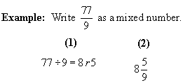
Step 1: Divide the numerator (77) by the denominator (9).
Step 2: Write the mixed number using the whole number quotient, 8, as the whole number and the remainder, 5, as the numerator. The denominator remains the same.
Once the student is comfortable with converting mixed fractions to improper fractions and improper fractions to mixed numbers, he or she is ready to move on to multiplying a mixed number by a whole number.
Example 1: Multiply. Reduce your answer to lowest terms.
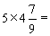
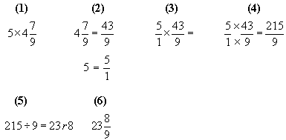
Step 1: Rewrite the problem.
Step 2: Rewrite 4 7/9 as an improper fraction and 5 as a fraction. Remember, to change a whole number into a fraction, write the whole number as the numerator with a denominator of 1.
Step 3: Rewrite the problem using the new forms of 5/1 and 43/9.
Step 4: Multiply the numerators and the denominators.
Step 5: In order to reduce the answer to lowest terms, the student will need to change the answer of 215/9 back into a mixed number. The first step to doing this is to divide the numerator by the denominator.
Step 6: Since 215 divided by 9 is 23 r8, 23 becomes the whole number and 8 becomes the numerator. The denominator will remain 9. The answer 23 and 8/9 cannot be reduced any further since 8 and 9 do not share any common factors.
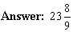
Example 2: Multiply. Reduce your answer to lowest terms.
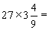
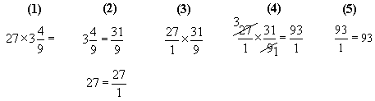
Step 1: Rewrite the problem.
Step 2: Rewrite 3 4/9 as an improper fraction and 27 as a fraction.
Step 3: Rewrite the problem using the new forms of 27/1 and 31/9.
Step 4: Before multiplying the numerators and the denominators, use cross cancellation to make the numbers in the problem more manageable. Since the numerator (27) and denominator (9) are both divisible by 9, divide both numbers by 9 and then perform the multiplication. 3 31 = 93 and 1 1 = 1.
Step 5: Since 93/1 is a whole number written as a fraction, remove the denominator to write 93 in its whole number form.
Answer: 93
***Cross cancellation is the process of reducing the numbers within a multiplication of fractions problem before multiplying the fractions. If a numerator and a denominator of any of the fractions to be multiplied can be divided by the same number, this division can be performed before the fractions are multiplied.
An activity to reinforce the concept of multiplying mixed numbers by a whole number is to create two stacks of flash cards. Write only whole numbers on the cards in one stack and only mixed numbers on the cards in the other stack. Place each stack separately into two brown paper bags. Have the student randomly pull one whole number and one fraction from each bag and calculate the product of the two numbers.

Multiply Fractions: Story Problems - B
In this skill, story problems, also called word problems, relate multiplication of fractions to actual situations. Operational symbols, such as the multiplication symbol, , are replaced with text. The problems in this skill set require the students to reduce.

Many students find story problems challenging. It may be useful to first confirm that students are comfortable with multiplying fractions. Then, they can move on to problems that are presented in story problem context.
The following is an example of the multiplication of two fractions with no reducing required.
Example 1:
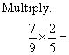
Solution: Multiply the numerators (the numbers on the top of the fraction), 7 2 = 14, and the denominators (the numbers on the bottom of the fraction), 9 5 = 45. The solution is 14/45.
Answer: 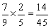
The following is an example of the multiplication of two fractions with reducing required.
Example 2:
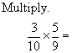
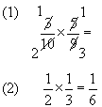
Step 1: Use cross cancellation to reduce the fractions before multiplying. Look for any numerator that has a common factor with any denominator.
• In this example, 3 and 9 share the factor 3, so it can be divided into both numbers to reduce them. Perform the divisions. 3 ÷ 3 = 1 and 9 ÷ 3 = 3.
• Also, 5 and 10 share the factor 5, so it can be divided into both numbers to reduce them. Perform the divisions. 5 ÷ 5 = 1 and 10 ÷ 5 = 2.
Step 2: Multiply the numerators, 1 1 = 1, and the denominators, 2 3 = 6. The solution is 1/6.
Answer:
An alternative method when multiplying fractions that can be reduced is to multiply through as usual and look for common factors in the resulting fraction.
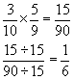
Multiplication of fractions, especially in the context of a story problem, can be confusing for students. It is important for them to remember that when multiplying two fractions between 0 and 1, the product is always a smaller fraction. This result is the opposite of what students are used to with whole number multiplication.
The following is an example of the multiplication of two fractions in the context of a story problem with no reducing required.
Example 3:
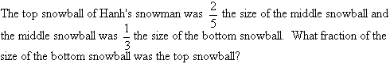
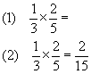Step 1: Determine that multiplication is required to solve the problem. To relate the bottom snowball to the top snowball, it is necessary to relate the bottom snowball to the middle snowball (1/3) and then the middle snowball to the top snowball (2/5). Multiply these two fractions to find the solution.
Step 2: Multiply the numerators, 1 2 = 2, and the denominators, 3 5 = 15. The solution is 2/15.
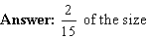
The following is an example of multiplying two fractions in the context of a story problem that requires reducing.
Example 4:
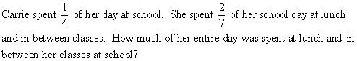
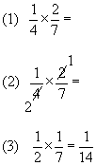
Step 1: Determine that multiplication is required to solve the problem. To relate Carrie's whole day to her time spent at lunch and in between classes, it is necessary to relate her whole day to the school day (1/4) and then the school day to the time spent at lunch and in between classes (2/7). The solution needed is 2/7 of 1/4 of her school day. Multiply 2/7 and 1/4 to find the solution.
Step 2: Simplify the fractions using cross cancellation. The numerator 2 and the denominator 4 both have a factor of 2 in common. Perform the divisions. 2 ÷ 2 = 1 and 4 ÷ 2 = 2.
Step 3: Multiply the numerators, 1 1 = 1, and the denominators, 2 7 = 14. The solution is 1/14.
An activity to help reinforce this skill is to create scenarios with the student. These can be scenarios such as determining the fraction of the front lawn that has flower beds. Then, determining the fraction of the flower beds with a specific type of flower (such as daffodils). Finally, have the student determine the fraction of the front yard that has the specific type of flower (daffodils). For example, if 1/8 of the front yard has flower beds and 2/3 of the flower beds are filled with daffodils, then 2/24 or 1/12 of the entire front yard is a flower bed with daffodils.

Subtract Fractions: Mixed Numbers - C
Subtracting mixed fractions requires a solid understanding of adding fractions and the multiplication table. If the numerator of a fraction is less than the denominator, the fraction is called a proper fraction. If the numerator is equal to or greater than the denominator, the fraction is called an improper fraction. An improper fraction can be rewritten as a mixed fraction. For example, 5/3 is an improper fraction. It can be rewritten as 1 2/3, which is a mixed fraction. The following is a step-by-step example of subtracting two mixed fractions.

Example 1: 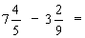
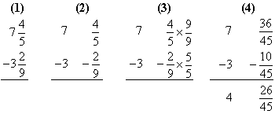Step 1: Write the problem vertically.
Step 2: Separate the problem into subtraction of whole numbers and subtraction of fractions.
Step 3: Find a common denominator (a common multiple of the denominators of two or more fractions) for the fractions. For this problem, the common denominator is 45. Multiply 4/5 by 9/9 to get 36/45. Multiply 2/9 by 5/5 to get 10/45.
Step 4: Subtract the whole numbers (7 - 3 = 4). Subtract the numerators (36 - 10 = 26). The denominator remains the same (45).
The following is a step-by-step example of subtracting two mixed fractions when the second fraction is larger than the first.
Example 2: 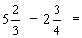
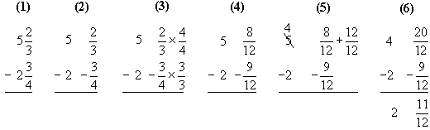
Step 1: Write the problem vertically.
Step 2: Separate the problem into subtraction of whole numbers and subtraction of fractions.
Step 3: Find a common denominator for the fractions. For this problem, the lowest common denominator is 12. Multiply 2/3 by 4/4 to get 8/12. Multiply 3/4 by 3/3 to get 9/12.
Step 4: Rewrite the problem with the fractions having common denominators.
Step 5: Since the top fraction (8/12) is smaller than the bottom fraction (9/12), trade (or borrow) one whole (12/12) from the 5 and add 12/12 to the 8/12 to get 20/12.
Step 6: Subtract the whole numbers (4 - 2 = 2). Subtract the numerators of the fractions (20 - 9 = 11). The denominator (12) remains the same.
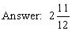

Lowest Terms - B
A fraction is comprised of two parts: a numerator (the top number) and a denominator (the bottom number). For example, in the fraction 2/3 the "2" is the numerator and the "3" is the denominator. A fraction is in lowest terms when the numerator and the denominator do not have a common factor greater than one.

Example 1: Reduce the fraction to lowest terms.
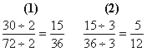
Step 1: Divide the numerator and the denominator by a common factor (2).
Step 2: The fraction (15/36) is still not in lowest terms. Divide the numerator and the denominator by a common factor (3).
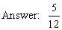
An improper fraction is a fraction in which the numerator is greater than or equal to the denominator. All improper fractions can be rewritten as mixed numbers or as whole numbers. The following is an example of how to write an improper fraction as a mixed number.
Example 2: Reduce all fractions to lowest terms.
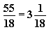
Solution: 18 will divide into 55 three times (18 x 3 = 54) with one left over. Write the 3 as a whole number and then make the fraction 1/18.
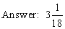

Lowest Common Denominator - B
The lowest common denominator (LCD) of two or more fractions is the least common multiple of the fractions' denominators.

Find the least common multiple of two denominators by finding the smallest non-zero number that is a multiple of each of the denominators. To find the LCD of two or more fractions, make a list of each of the denominators' multiples. Then determine the smallest number that is a multiple of all of the denominators.
Example 1:
Multiples of the denominators:
Multiples of 3: 3, 6, 9, 12, 15, 18, 21, 24, 27, 30, 33, 36,...
Multiples of 4: 4, 8, 12, 16, 20, 24, 28, 32, 36,...
Multiples of 9: 9, 18, 27, 36,...
The smallest common multiple is 36. This multiple (36) is the lowest common denominator for the three fractions.

